Acceptance tests   
“Acme Rookies v1.0”

|  |  |
| --- | --- |
| Development team | |
| **Identifier** | *G56* |
| **Members** | *Gomez, Alejandro; Negrón, Daniel; Gil, David; Hermoso, Roberto; Alonso Valenzuela, Juan Carlos; García Barco, Pablo* |
| **Testing team** | |
| **Identifier** |  |
| **Members** |  |
| **Indexing data** | |
| **Test designers** | *Gomez, Alejandro; Negrón, Daniel; Gil, David; Hermoso, Roberto; Alonso Valenzuela, Juan Carlos; García Barco, Pablo* |
| **Testers** |  |
| **Notes** |  |

**Table of contents**

Use case UC1: Register to the system as a company 5

Use case UC2: Register to the system as a rookie 8

Use case UC3: Search for a position using a single key word that must be contained in its title, its description, its profile, its skills, its technologies, or the name of the corresponding company. 11

Use case UC4: Broadcast Message 13

Use case UC5: Broadcast rebranding message 14

Use case UC6: Launch a process that flags the actors of the system as spammers or not-spammers. A user is considered to be a spammer if at least 10% of the messages that he or she’ contain at least one spam word. Ban an actor, Unban an actor 17

Use case UC7: Logged as admin, register a new auditors 20

Use case UC8: Logged as Auditor, delete your account 24

Use case UC9: Logged as Auditor, export your data 25

Use case UC10: Logged as Auditor, edit your personal data 27

Use case UC11: Do the same as an actor authenticated (Auditor and provider) 29

Use case UC12: See terms and conditions (Auditor and provider) 30

Use case UC13: Logged as Provider, delete your account 31

Use case UC14: Logged as Provider, export your data 32

Use case UC15: Logged as Provider, edit your personal data 34

Use case UC16: Logged as provider, list and show his sponsorships 36

Use case UC17: Logged as provider, create a sponsorship 37

Use case UC18: Logged as provider, edit or delete an sponsorship 46

Use case UC19: Logged as company, list and show his or her position 52

Use case UC20: Logged as company, create position 54

Use case UC21: Logged as company, edit or delete a position 57

Use case UC22: Logged as company, listing and showing his or her problems 60

Use case UC23: Logged as company, create a problem 62

Use case UC24: Logged as company, edit or delete a problem 66

Use case UC25: Logged as company, list the position’s applications. 68

Use case UC26: Logged as company, change the status of an application 71

Use case UC27: Authenticated as any role or not, browse the list of providers and navigate to their items. 74

Use case UC28: Authenticated as any role or not, browse the list of items and navigate to their providers. 76

Use case UC29: Not authenticated, register to the system as a provider. 79

Use case UC30: Logged as rookie, list and filter his or her applications 85

Use case UC31: Logged as rookie, create an application 89

Use case UC32: Logged as rookie, update an application 92

Use case UC33: Logged as provider, list and show his or her items 97

Use case UC34: Logged as provider, create an item 100

Use case UC35: Logged as provider, edit an item 104

Use case UC36: Logged as provider, delete an item 106

Use case UC37: Logged as auditor, list and show his assignable positions to audit 108

Use case UC38: Logged as auditor, create an audit 113

Use case UC39: Logged as Auditor, list his audits. 119

Use case UC40: Logged as auditor, edit or delete an Audit 122

Use case UC41: Logged as Admin, update the score of the Companies of the system 126

Use case UC42: Logged as admin, display a Dashboard with the following information 128

Use case UC43: Logged as admin, display a Dashboard with the following information 130

Use case UC44: Logged as admin, display a Dashboard with the following information 132

Use case UC45: Logged as admin, display a Dashboard with the following information 135

Use case UC46: Logged as admin, display a Dashboard with the following information 137

Use case UC47: Logged as rookie, list curriculums 139

Use case UC48: Logged as rookie, edit curriculums 141

Use case UC49: Logged as rookie, edit Position Data 145

Use case UC50: Logged as rookie, edit Education Data 150

Use case UC51: Logged as rookie, edit Miscellaneous Data 156

Use case UC52: Logged as rookie, delete Data and Curriculum 161

Use case UC53: Logged as rookie, create Curriculum 164

Use case UC54: Logged as rookie, Data protection 167

Use case UC55: Logged as any actor, list your social profiles 172

Use case UC56: Logged as actor, create a Social Profile and edit one of your Social Profiles 176

Use case UC57: Logged as Actor, list your messages. 182

Use case UC58: Logged as actor, send a message 185

Additional tests 191

# Use case UC1: Register to the system as a company

Description

*An unauthenticated user wants to register to the system; he or she fills in a form with personal data and user account data; finally, he or she hits the ‘Save button”.*

Access

*While not logged, click in register and then in Register as company*

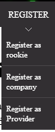

*Fill the data*

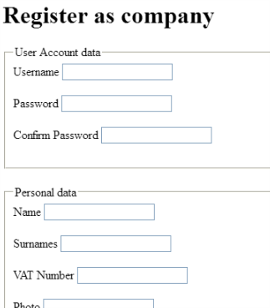

*Finally, click in save button*

**

Tests

|  |  |
| --- | --- |
| Test 1 | |
| **Description** | *“The form must be filled in with the following data:* ***Username****: ‘company99,* ***Password****: company99,* ***Confirm******password****: ‘company99,* ***Name****: ‘name’,* ***Surnames:*** *‘surnames’,* ***VAT Number****: ‘ATU00000024’,* ***Photo****: ‘https://www.photo.com’,* ***Email****: ‘company99@gmail.com’,* ***Phone******Number****: ‘+34666555444’,* ***Address****: ‘Fake street’,* ***Company name****: company99Name,* ***Holder******name****: ‘company99,* ***Brand******name****: ‘VISA’,* ***Number****: ‘4406564128950612’,* ***Expiration******month****: ‘12’,* ***Expiration******year****: ‘22’, Cvv code: ‘123’,* ***Terms and Conditions*** *‘Check the box ”.* |
| **Expected** | *When you click on save, the page will redirect you to the main page.* |
| **Outcome** | *Following the steps in the description* |
| **Notes** | *The terms of service page does not have a return button.*  *If you re-register a user with the same data the system is not able to save it, however it does not tell me what the error is, it simply indicates "commit error".*  *As a user I would like you to tell me what the problem is (same username, email ...).*      *According to European regulations, the VAT number consists of 2 letters, in the case of an example it has 3 and it is considered a valid value.*  <https://en.wikipedia.org/wiki/VAT_identification_number>    *If you delete the browser cache and go directly to the URL http://localhost/security/login.do the system logo does not appear.* |

|  |  |
| --- | --- |
| Test 2 | |
| **Description** | *The user must click on save without entering any data in the form.* |
| **Expected** | *The page will show all corresponding error messages* |
| **Outcome** |  |
| **Notes** | *The name of the company is a mandatory parameter. If the form is sent completely blank, the obligatory nature of this parameter is not indicated.*    *If the user edits the HTML and deletes the T.O.S acceptance field, a panic message appears. Although it occurs with any fielset that is removed.* |

|  |  |
| --- | --- |
| Test 3 | |
| **Description** | *The user put all the correct data, but blank phone* |
| **Expected** | *The system will display a message warning that the phone will be blank.* |
| **Outcome** |  |
| **Notes** | *As a standard user of the application I miss the use of a* ***placeholder pattern****, for example, in the fields of the credit card.*  *I made an error when filling out the card number, and although it is very evident, I would have a placeholder help.*  ***\* DELETE THIS * Very good validation of the card, guys!*** |

|  |  |
| --- | --- |
| Test 4 | |
| **Description** | *The user put all the correct data, but a phone with more than 4 numbers and no +34* |
| **Expected** | *The system will display a message warning that the phone doesn’t have the correct format, after click in confirm, the user will be created.* |
| **Outcome** |  |
| **Notes** | *As indicated in the test 1 notes, if a user is filled with the same data, a commit error is returned instead of the cause of the error.*  *I imagine that a software like this on a large scale can occur in many cases the repetition of the username and would be more related to the user to indicate, for example, that user is already chosen.* |

|  |  |
| --- | --- |
| Test 5 | |
| **Description** | *The user put a correct month for the credit card, but not a correct year.*  *Expiration month should be filled with ‘12’, Expiration year should be filled with ‘12’* |
| **Expected** | *The view will show ‘The credit card cannot be expired’ in the* ***Expiration******month*** *input* |
| **Outcome** |  |
| **Notes** | *Consciously blank.* |

# Use case UC2: Register to the system as a rookie

Description

*“An unauthenticated user wants to register to the system; he or she fills in a form with personal data and user account data; finally, he or she hits the ‘Save button”.*

Access

*While not logged, click in register and then in Register as rookie*

**

*Fill the data*

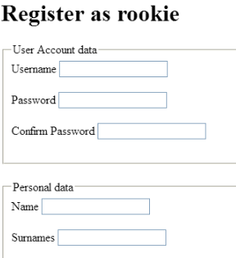

*Finally, click in save button*

**

Tests

|  |  |
| --- | --- |
| Test 1 | |
| **Description** | *“The form must be filled in with the following data:* ***Username****: ‘rookie99,* ***Password****: rookie99,* ***Confirm******password****: ‘rookie99,* ***Name****: ‘name’,* ***Surnames:*** *‘surnames’,* ***VAT Number****: ‘ATU00000024’,* ***Photo****: ‘https://www.photo.com’,* ***Email****: ‘company99@gmail.com’,* ***Phone******Number****: ‘+34666555444’,* ***Address****: ‘Fake street’,* ***Holder******name****: ‘rookie99,* ***Brand******name****: ‘VISA’,* ***Number****: ‘4406564128950612’,* ***Expiration******month****: ‘12’,* ***Expiration******year****: ‘22’, Cvv code: ‘123’,* ***Terms and Conditions*** *‘Check the box ”.* |
| **Expected** | *When you click on save, the page will redirect you to the main page.* |
| **Outcome** |  |
| **Notes** | *Same error as test 1 of the previous use case.* |

|  |  |
| --- | --- |
| Test 2 | |
| **Description** | *The user must click on save without entering any data in the form.* |
| **Expected** | *The page will show all corresponding error messages* |
| **Outcome** |  |
| **Notes** | *The same error occurs when editing HTML, deleting any fieldset and saving.* |

|  |  |
| --- | --- |
| Test 3 | |
| **Description** | *The user put all the correct data, but blank phone* |
| **Expected** | *The system will display a message warning that the phone will be blank.* |
| **Outcome** |  |
| **Notes** | *Consciously blank.* |

|  |  |
| --- | --- |
| Test 4 | |
| **Description** | *The user put all the correct data, but a phone with more than 4 numbers and no +34* |
| **Expected** | *The system will display a message warning that the phone doesn’t have the correct format, after click in confirm, the user will be created.* |
| **Outcome** |  |
| **Notes** | *Same error as test 4 of the previous use case.* |

|  |  |
| --- | --- |
| Test 5 | |
| **Description** | *The user put a correct month for the credit card, but not a correct year.*  *Expiration month should be filled with ‘12’, Expiration year should be filled with ‘12’* |
| **Expected** | *The view will show ‘The credit card cannot be expired’ in the* ***Expiration******month*** *input* |
| **Outcome** |  |
| **Notes** | *Consciously blank.* |

# Use case UC3: Search for a position using a single key word that must be contained in its title, its description, its profile, its skills, its technologies, or the name of the corresponding company.

Description

*An unauthenticated or authenticated user wants to search for a position, put a keyword in the filter, and will be shown to him all the public positions with these criteria.*

Access

*Click in public positions logged as an actor or not.*

**

*Put a keyword.*

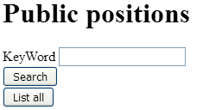

*If you click in list All, it will show you all the public positions.*

*If you click in search with a keyword, will search all the position with the keyword.*

Tests

|  |  |
| --- | --- |
| Test 1 | |
| **Description** | *“Put in the search bar the word* ***‘1’*** *”.* |
| **Expected** | *When you click on search, the page will show to you 2 positions* |
| **Outcome** | *No positions were found using the key “1”* |
| **Notes** | *Notice that it search if any of the content have the number 1, if you search ‘****osition****’, will search all the words with ‘****osition’*** *on it* |

# Use case UC4: Broadcast Message

Description

Logged in as an administrator, you must be able to send a message to all the actors in the system.

Access

Login as admin

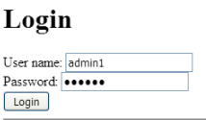

Go to administrator menu and click in Broadcast notification

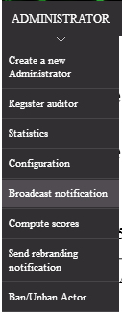

You need to fill the message form, notice that the defect tag is SYSTEM, but you can change it

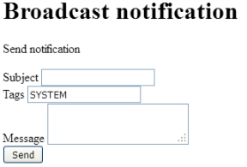

Then click in send and the message will be broadcasted

Tests

|  |  |
| --- | --- |
| Test 1 | |
| **Description** | *“The form must be filled with the following data:* ***Subject****: ‘Notification’,* ***Message****: ‘This is a notification’ “* |
| **Expected** | *After click in send button, we will be redirected to the main page* |
| **Outcome** |  |
| **Notes** | *Admin will have only 1 message sent.*  *In my opinion it would be more intuitive if after sending the message the user was redirected to his P.O. box.*  *The administrator has two initial messages. One of them cannot be deleted unless the second one is deleted.* |

|  |  |
| --- | --- |
| Test 2 | |
| **Description** | *“Delete the defect value SYSTEM in tag value and send notification with all the values in blank”* |
| **Expected** | *After click in send button, the page will show the form error messages* |
| **Outcome** |  |
| **Notes** | *Consciously blank.* |

# Use case UC5: Broadcast rebranding message

Description

Logged in as an administrator, you must be able to send a message to all the actors informing that the system has changed of name. This message can only be sent 1 time

Access

Log in as admin



Click in Send rebranding notification (This button will disappear once the method is used).

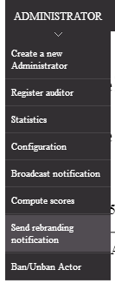

The message will be autofilled with all necessary data.

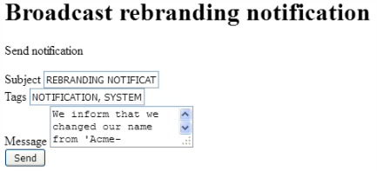

Click in send and message will be sent.

Tests

|  |  |
| --- | --- |
| Test 1 | |
| **Description** | *“Click in send button and don’t any additional data”* |
| **Expected** | *After click in send button, we will be redirected to the main page* |
| **Outcome** |  |
| **Notes** | *You can only use this method once*  *If I delete the notification I just sent from my message box, the button that enables this option reappears.* |

|  |  |
| --- | --- |
| Test 2 | |
| **Description** | *“Access to the URL manually”.* |
| **Expected** | *“Put in the browser : ‘localhost:8080/Acme-Rookies/broadcast/administrator/sendRebranding.do’”. You will be redirected to main page.* |
| **Outcome** |  |
| **Notes** | *Consciously blank.* |

# Use case UC6: Launch a process that flags the actors of the system as spammers or not-spammers. A user is considered to be a spammer if at least 10% of the messages that he or she’ contain at least one spam word. Ban an actor, Unban an actor

Description

Logged as administrator, you must be capable of see a view with updated suspicious / non suspicious actors.

Is needed that an actor send an spam message to verify this process run.

Access

Log in as rookie

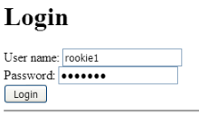

Click in your profile, then in messages

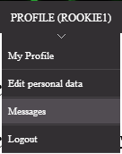

Click in new message



Send a message with spam

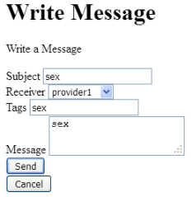

Log in as admin



Click in Ban/Unban actor

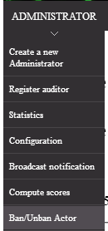

Go to page 5 and you will see the Rookie1 we sended the message with the suspicious flag

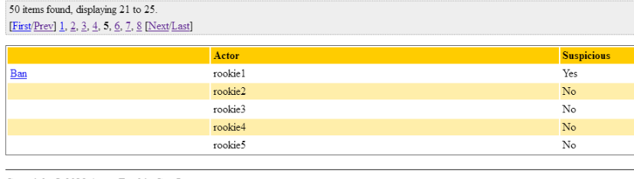

Ban it, try to login with rookie1

Then unban it, and try to log in again

Tests

|  |  |
| --- | --- |
| Test 1 | |
| **Description** | *“Logged as rookie1 Send 1 message with ‘sex’ word and then logged as admin1 go to ban/Unban view”* |
| **Expected** | *Rookie 1 will have ‘suspicious’ flag* |
| **Outcome** |  |
| **Notes** | *Rookie 1 is in the page five.* |

|  |  |
| --- | --- |
| Test 2 | |
| **Description** | *“Logged as rookie2, send 10 message with no spam word, then send 1 message with ‘sex’ word, then logged as admin1 go to ban/unban view”* |
| **Expected** | *Rookie 2 will not have ‘suspicious’ flag because 10% of his/her messages are not spam* |
| **Outcome** |  |
| **Notes** | *First of all the tag is reconfigured by F- and does not use the one I configured as user.*  *Secondly, the banning system does not take into account the deletion of messages.*  *Let's say that after sending 10 correct messages and 1 with sex I decide to delete two messages completely from the account of the sender and receiver (it should be deleted completely from the system). After this step should be enabled the option to ban the user, which does not happen.*        *If the user knows the rookie ID 2 and tries to perform a GET hacking a panic message appears. Even if he enter a ID that does not exist.* |
|  |  |

|  |  |
| --- | --- |
| Test 3 | |
| **Description** | *“Logged as admin, after you do the Test1, go to ban/unban view and ban rookie1, then unlog and log with rookie1”* |
| **Expected** | *You won't be able to log in.* |
| **Outcome** |  |
| **Notes** | *Consciously blank.* |

|  |  |
| --- | --- |
| Test 4 | |
| **Description** | *“Logged as admin, after you do the Test3, go to ban/unban view and unban rookie1, then unlog and log with rookie1”* |
| **Expected** | *You will be able to log in as rookie1.* |
| **Outcome** |  |
| **Notes** | *Consciously blank.* |

# Use case UC7: Logged as admin, register a new auditors

Description

*An user logged as admin can create new accounts for auditors*

Access

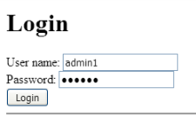

Logged as admin, click in ADMINISTRATOR

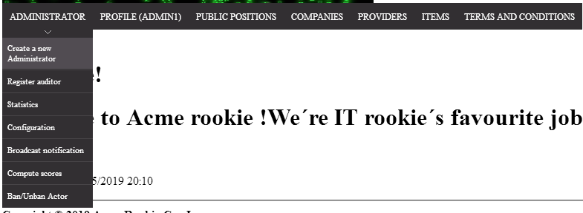

Then, click in register auditor

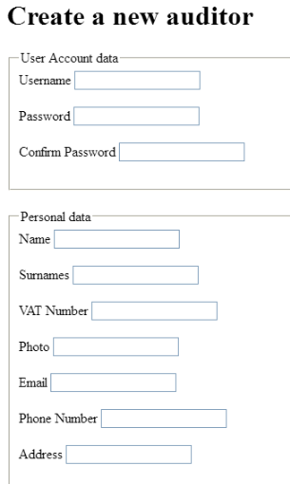

Now you can fill the form to register a new auditor



And then click in the save button

Tests

|  |  |
| --- | --- |
| Test 1 | |
| **Description** | *“The form must be filled in with the following data:* ***Username****: ‘auditor99,* ***Password****: auditor99,* ***Confirm******password****: ‘auditor99,* ***Name****: ‘name’,* ***Surnames:*** *‘surnames’,* ***VAT Number****: ‘ATU00000024’,* ***Photo****: ‘https://www.photo.com’,* ***Email****: ‘auditor9999@gmail.com’,* ***Phone******Number****: ‘+34666555444’,* ***Address****: ‘Fake street’,* ***Holder******name****: ‘provider99’,* ***Brand******name****: ‘VISA’,* ***Number****: ‘4406564128950612’,* ***Expiration******month****: ‘12’,* ***Expiration******year****: ‘22’, Cvv code: ‘123’,* ***Terms and Conditions*** *‘Check the box ”.* |
| **Expected** | *When you click on save, the page will redirect you to the main page* |
| **Outcome** |  |
| **Notes** | *Take care you don’t add a space at the end of VAT number*  *As I said in my first test, the VAT number does not comply with European regulations as well as not identical error of repetition of the same user, indicating it as a general error when saving, being a little confusing.* |

|  |  |
| --- | --- |
| Test 2 | |
| **Description** | *The user must click on save without entering any data in the form.* |
| **Expected** | *The page will show all corresponding error messages* |
| **Outcome** |  |
| **Notes** | *If the user edits the html, deletes the confirmation of the terms of use and tries to save an auditor a panic message appears.* |

|  |  |
| --- | --- |
| Test 3 | |
| **Description** | *The user put all the correct data, but blank phone* |
| **Expected** | *The system will display a message warning that the phone will be blank.* |
| **Outcome** |  |
| **Notes** | *Consciously blank.* |

|  |  |
| --- | --- |
| Test 4 | |
| **Description** | *The user put all the correct data, but a phone with more than 4 numbers and no +34* |
| **Expected** | *The system will display a message warning that the phone doesn’t have the correct format, after click in confirm, the user will be created.* |
| **Outcome** |  |
| **Notes** | *Consciously blank.* |

|  |  |
| --- | --- |
| Test 5 | |
| **Description** | *The user put a correct month for the credit card, but not a correct year.*  *Expiration month should be filled with ‘12’, Expiration year should be filled with ‘12’* |
| **Expected** | *The view will show ‘The credit card cannot be expired’ in the* ***Expiration******month*** *input* |
| **Outcome** |  |
| **Notes** | *Consciously blank.* |

# Use case UC8: Logged as Auditor, delete your account

Description

An user logged as Auditor must be capable of delete his account

Access

Log as auditor1

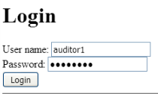

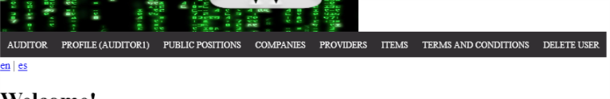

In the header, click in the last option ‘Delete user’,

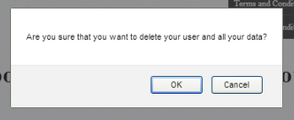

Click in the confirmation

Tests

|  |  |
| --- | --- |
| Test 1 | |
| **Description** | *“Delete your account”* |
| **Expected** | *The user and all his/her data will be deleted from the system and you will be redirected to main page unlogued* |
| **Outcome** |  |
| **Notes** | *All the actor data must be deleted* |

# Use case UC9: Logged as Auditor, export your data

Description

An user logged as Auditor must be capable of export all his personal data in a txt file.

Access

Log in has auditor



Access to your profile and click in ‘My profile’

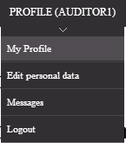

Click in Export button

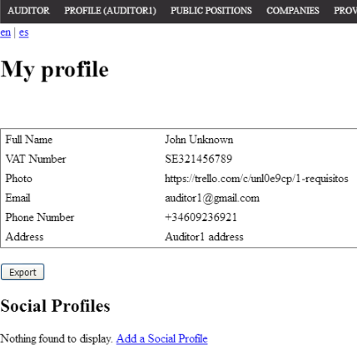

Save the file in your system

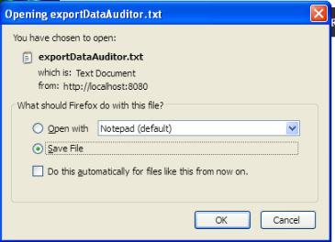

Tests

|  |  |
| --- | --- |
| Test 1 | |
| **Description** | *“Export your personal data”* |
| **Expected** | *You will have a downloaded file in your system with all the auditor personal data* |
| **Outcome** |  |
| **Notes** | *Depending on the browser, the information will appear sorted or not*  *As far as I understand it, personal data is all your information, including his audits* *as well as his credit card details.. It's an opinion and it doesn't have to be the right one* |

# Use case UC10: Logged as Auditor, edit your personal data

Description

An actor logged as Auditor must be capable of edit his or her personal information.

Access

Log in as auditor



Access to your profile and click in ‘My profile’

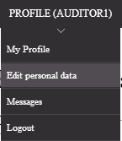

Edit your personal data

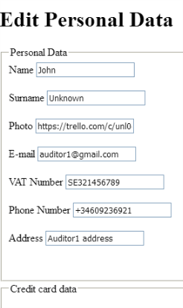

Then click in save



You will be redirected to your profile:

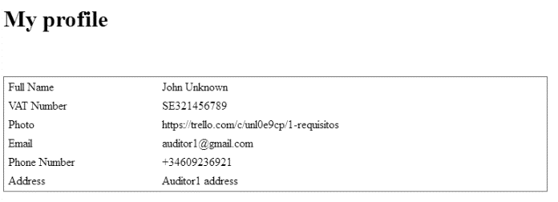

Tests

|  |  |
| --- | --- |
| Test 1 | |
| **Description** | *“Edit your personal data”* |
| **Expected** | *“You will change the current form data for the following.*  ***Name****: ‘John99’,* ***Surname****: ‘Unknown99’,* ***Photo****: ‘https://trello99.com’,* ***E-mail****: ‘auditor99@gmail.com’,* ***VAT******Number****: ‘ATU00000024’,* ***Phone******number****: ‘+34609236920’,* ***Address****: ‘Auditor99 address’,* ***Holder******name****: ‘Auditor 99’,* ***Brand******name****: ‘MASTER’,* ***Number****: ‘4259005652536003’,* ***Expiration******month****: ‘10’,* ***Expiration******year****: ‘24’,* ***Cvv code****: ‘234’”* |
| **Outcome** |  |
| **Notes** | *Why doesn't information like credit card appear in my profile if the card editing is done from the profile editing?* |

|  |  |
| --- | --- |
| Test 2 | |
| **Description** | *“Put all the data in blank”* |
| **Expected** | *You will obtain all the form errors* |
| **Outcome** |  |
| **Notes** | *Consciously blank.* |

# Use case UC11: Do the same as an actor authenticated (Auditor and provider)

Description

An actor logged as Auditor or provider must be able to access to al public data like an anonymous actor

Access

Log in as auditor

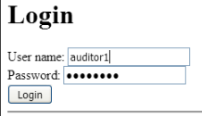 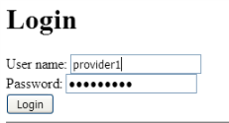

Access to all the disponible public data

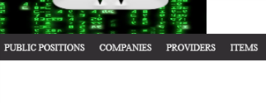

Tests

|  |  |
| --- | --- |
| Test 1 | |
| **Description** | *“Access to all public data”* |
| **Expected** | *“You must be able to access the public positions, their problems, their applications, their company and their audits.*  *Access companies and their positions*  *Access to providers and their items*  *Access items and their providers”* |
| **Outcome** |  |
| **Notes** | *Note that all the back buttons must be 100% functional.*  *If you for example are logged as auditor, in the public data of audits, you will be capable of do actions on this audits.* |

# Use case UC12: See terms and conditions (Auditor and provider)

Description

Access to Spanish and English terms and conditions

Access

Log as provider of auditor

 

Click in terms and conditions and access to English or Spanish terms

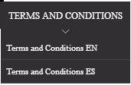

*Tests*

|  |  |
| --- | --- |
| Test 1 | |
| **Description** | *“Access to terms and conditions”* |
| **Expected** | *“The Terms and Conditions must explain the standard ‘Terms and conditions’ of any company”* |
| **Outcome** |  |
| **Notes** | *Everything must refer to Acme-Rookies* |

# 

# Use case UC13: Logged as Provider, delete your account

Description

An user logged as Provider must be capable of delete his account

Access

Log as provider1



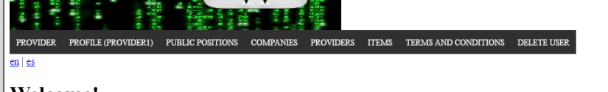

In the header, click in the last option ‘Delete user’,



Click in the confirmation

*Tests*

|  |  |
| --- | --- |
| Test 1 | |
| **Description** | *“Delete your account”* |
| **Expected** | *The user and all his/her data will be deleted from the system and you will be redirected to main page unlogued* |
| **Outcome** |  |
| **Notes** | *All the actor data must be deleted* |

# Use case UC14: Logged as Provider, export your data

Description

An user logged as Provider must be capable of export all his personal data in a txt file.

Access

Log in has provider



Access to your profile and click in ‘My profile’

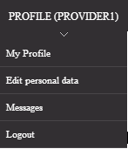

Click in Export button

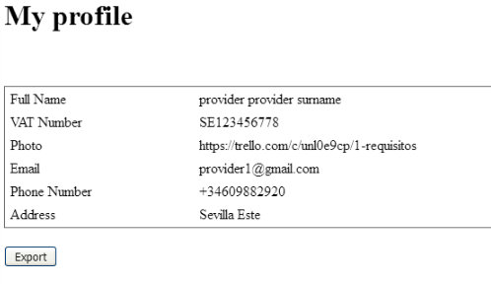

Save the file in your system

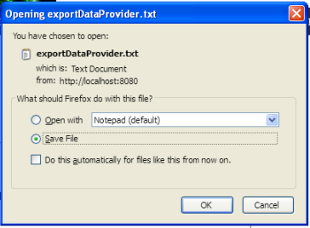

*Tests*

|  |  |
| --- | --- |
| Test 1 | |
| **Description** | *“Export your personal data”* |
| **Expected** | *You will have a downloaded file in your system with all the provider personal data* |
| **Outcome** |  |
| **Notes** | *Depending on the browser, the information will appear sorted or not in the text file.* |

# Use case UC15: Logged as Provider, edit your personal data

Description

An actor logged as Provider must be capable of edit his or her personal information.

Access

Log in as provider



Access to your profile and click in ‘My profile’



Edit your personal data

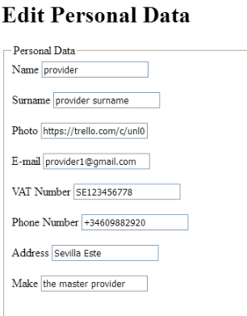

Then click in save



You will be redirected to your profile:

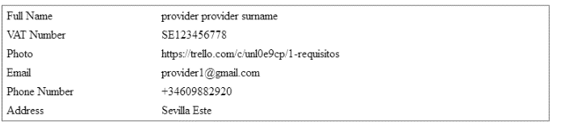

*Tests*

|  |  |
| --- | --- |
| Test 1 | |
| **Description** | *“Edit your personal data”* |
| **Expected** | *“You will change the current form data for the following.*  ***Name****: ‘provider11,* ***Surname****: ‘provider surname,* ***Photo****: ‘https://trello.com,* ***E-mail****: ‘provider11@gmail.com,* ***VAT******Number****: ‘SE123456778,* ***Phone******number****: ‘+34619882920,* ***Address****: ‘Sevilla Este’,* ***Make****: ‘the master’* ***Holder******name****: ‘Provider One,* ***Brand******name****: ‘MASTER’,* ***Number****: ‘4259005652536003’,* ***Expiration******month****: ‘10’,* ***Expiration******year****: ‘24’,* ***Cvv code****: ‘234’”* |
| **Outcome** |  |
| **Notes** |  |

|  |  |
| --- | --- |
| Test 2 | |
| **Description** | *“Put all the data in blank”* |
| **Expected** | *You will obtain all the form errors* |
| **Outcome** |  |
| **Notes** |  |

# Use case UC16: Logged as provider, list and show his sponsorships

*Description*

An user logged as an provider must be able to list her sponsorships. An provider can only create a sponsorship to positions in final mode.

*Access*

Homepage > Header Menu > Login

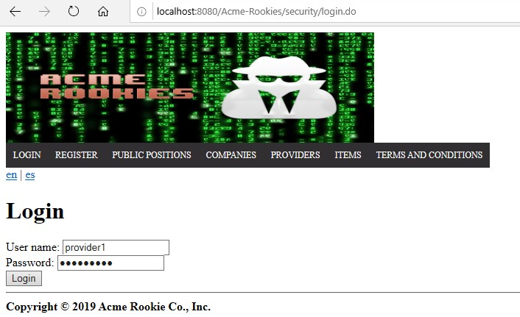

Login as “provider1/provider1”  > Header Menu > Display the "Provider" options > Sponsorships

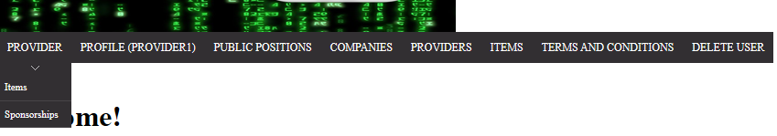

The list of sponsorships will be displayed

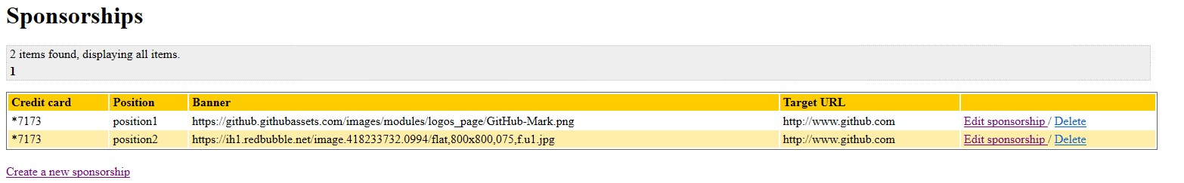

*Tests*

|  |  |
| --- | --- |
| **Test 1** | |
| **Description** | *We must be able to access to the creation form when the “Create a new sponsorship” button is clicked.* |
| **Expected** | *The Create a new sponsorship button must be visible under the list of sponsorships. It must redirect to the sponsorship creation (/sponsorship/provider/create.do) form correctly.* |
| **Outcome** |  |
| **Notes** |  |

|  |  |
| --- | --- |
| **Test 2** | |
| **Description** | *Redirect links must work correctly* |
| **Expected** | *The links referring to the sponsorship edit and the delete edit must redirect to the edit form of the sponsorship and to the list of sponsorships after deleting the selected sponsorship respectively.* |
| **Outcome** |  |
| **Notes** |  |

|  |  |
| --- | --- |
| **Test 3** | |
| **Description** | *Pagination links must work correctly* |
| **Expected** | *When the list of sponsorships is displayed, the pagination links must allow the user to navigate to the next, previous, first and last page. The pagination will also allow the user to select a specific page by selecting the number of that page.* |
| **Outcome** |  |
| **Notes** |  |

|  |  |
| --- | --- |
| **Test 4** | |
| **Description** | *The system is available in two languages, so it must work correctly in both cases.* |
| **Expected** | *Changing the language, the expected results must be obtained in all the tests indicated above.* |
| **Outcome** |  |
| **Notes** |  |

# Use case UC17: Logged as provider, create a sponsorship

*Description*

An user logged as provider can create a sponsorship.

Access

First of all, the user must log as provider in the login page. User: provider1, Password: provider1



Consequently, the user will display the list of sponsorships and click in the Create sponsorship button.

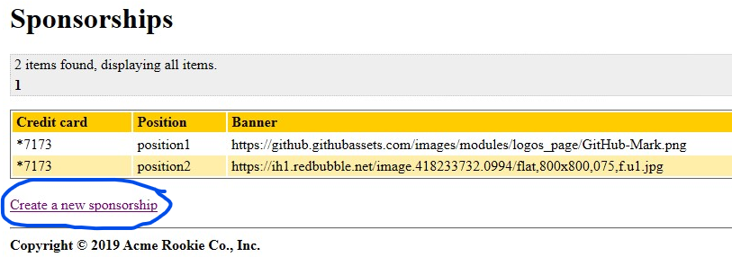

The following form should be displayed:

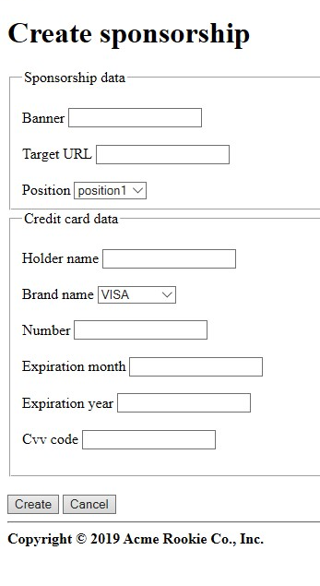

*Tests*

|  |  |
| --- | --- |
| **Test 1** | |
| **Description** | Insert valid data in the form, the user must provide a banner url (for example “http://www.example.com”), a target url (for example “<http://www.example.com>”), select a position (which is in final mode) and a valid credit card. |
| **Expected** | The user will be redirected to the list of his sponsorships(/sponsorship/provider/list.do). The new sponsorship should be visible at the end of the list with the last four digits of the credit card, the position, the banner and the target URL. Delete and Edit link are shown in the last column.  https://lh3.googleusercontent.com/h9WgM3FtOYigmjPftkl8sfB22eeCdiUQA2fwpu4X573ucbUx6dSeRN1Bxh5q5dhNQZRMam-6hfaWzxP3aslxRBt86Rhw_ugsH6scnPola0Ka0zv_TcmcEP1EJcoHVcKwFaux1ZgC  https://lh4.googleusercontent.com/PXFNhgQmKJZS6LLWmLL10UCjXXR7A9NRRy_lbAwsbXJ1jD_TotTh8iCuPbe2KnNq4H51MIkr_tU_FBQ07XqBMg4-kDEL9zGbCHEtUTeMO4iZ-YQU7cz8bXjdyx6JCaKdVzs85u2m |
| **Outcome** |  |
| **Notes** |  |

|  |  |
| --- | --- |
| **Test 2** | |
| **Description** | The user clicks in the “Cancel” Button. |
| **Expected** | When the user access to the Creation form, if he clicks in the “Cancel” button, he will be redirected to the list of her sponsorships (/sponsorships/provider/list.do).  https://lh4.googleusercontent.com/iXvFaqRQm4LoLfrM0k23cmGBydIi_WMJFBLwhOvLD9XHlUIFpIlCRUEtvtOtfaPySdRV2-EPF0h7GcWr8ArH9_h_bslFx0nR26s6lqUtc0bbMtpN23eCFidwq6mFSaH1k4H9wEIj  https://lh6.googleusercontent.com/twI2w4WrYykVQrMpFANZ1LSp8SbhqSNmRO61p1H6N4Ror110j-LRlKseJ7Tk1tJT6-ih0I8mlm_sSUKds748dXWzszO6yiXoO9xV3rGWhvliRnK4KFgoj829cXcIlA-o1pGHEUQx |
| **Outcome** |  |
| **Notes** |  |

|  |  |
| --- | --- |
| **Test 3** | |
| **Description** | The user provides a blank banner. |
| **Expected** | The sponsorship won’t be saved in the system and a message indicating that the banner cannot be blank will be shown.  https://lh4.googleusercontent.com/XH4qvJDRbnzWAbFtMrQ1P7p1_ecHgLkYBTB8xPEVeaPN2m8BS2VfX5lgIodRrH_E4NLItvMt69ld3NMcYtIcHQdjcDrTsAj9V3eZo8nIjZG27yb3mQZN0WoHPKoDHPpbuBmW-61E |
| **Outcome** |  |
| **Notes** |  |

|  |  |
| --- | --- |
| **Test 4** | |
| **Description** | The user provides a blank target URL. |
| **Expected** | The sponsorship won’t be saved in the system and a message indicating that the target URL cannot be blank will be shown.  https://lh3.googleusercontent.com/NaQ-DOsbJAk1sBh0vh3zdmbwSS9e-kWaJ-vjtECF4TDo5tT1Hy6oxSOsXelXB5W_n5y_v1eTmqkobKgdgwDOEDCV8ziVML5Kl4yTYWETmPTwOfNZUEgJ626nADXxrjIWi2C3F52e |
| **Outcome** |  |
| **Notes** |  |

|  |  |
| --- | --- |
| **Test 5** | |
| **Description** | The user provides a invalid banner URL. |
| **Expected** | The sponsorship won’t be saved in the system and a message indicating that the banner URL is invalid will be shown.  https://lh4.googleusercontent.com/I1J8Sk1qVoAtDid51he91g-vpLxrqDAHGbYysvmXSmZyrpmJzEygjlaL7SaijjHEG0P7pXugABW4HtM0DUT89gbCcCxbskS2cjX7kPwihFx26u-PHwrCliZ4-_2Lfo5piIA3SJCI |
| **Outcome** |  |
| **Notes** |  |

|  |  |
| --- | --- |
| **Test 6** | |
| **Description** | The user provides a invalid target URL. |
| **Expected** | The sponsorship won’t be saved in the system and a message indicating that the target URL is invalid will be shown.  https://lh3.googleusercontent.com/3YD-unfdnTIzzHiXzXXeR4wgD5Z5Zj5172382GOoUdoiEq5QBKtu6jfoWvkHhTal2vQV1WKyEpuvs13QevfwhOa_6ApktlGwamantp6iqdUMjIsUaUFiwHEmYQG3skWNZmFmEedV |
| **Outcome** |  |
| **Notes** |  |

|  |  |
| --- | --- |
| **Test 7** | |
| **Description** | The user provides a blank holder name. |
| **Expected** | The sponsorship won’t be saved in the system and a message indicating that the holder name cannot be blank will be shown.  https://lh4.googleusercontent.com/5M3AzVu-JfsHnSerUBtAeq6tYqtUDHZT-ki2fpBqd3-d-x2S2eRazWyitefQzz6AOWapSq5KX7Ee48r4OZ4gOI2FBFUDb9f2TdWZXPkGbgtgY3MhJH7hxpm7kYtEaxFZkeIaefor |
| **Outcome** |  |
| **Notes** |  |

|  |  |
| --- | --- |
| **Test 8** | |
| **Description** | The user provides a null card number. |
| **Expected** | The sponsorship won’t be saved in the system and a message indicating that the card number cannot be null will be shown.  https://lh6.googleusercontent.com/Ue_MsuZzaoK-ocL4Vpk-7-ie2Yd-DmjATm3SNpczBEhwDk2jKVoyuDzWh1m_Y6lPotWh8hYmSq_7U3qVv8iRB3QY85CuJ2t5Xhhqkucsot63f_yePI4J30ImTRGsgrP1ATSK1Sne |
| **Outcome** |  |
| **Notes** |  |

|  |  |
| --- | --- |
| **Test 9** | |
| **Description** | The user provides a null expiration month. |
| **Expected** | The sponsorship won’t be saved in the system and a message indicating that the expiration month cannot be null will be shown.  https://lh6.googleusercontent.com/Rdv4Oe0xz6R9D4EA8RuARKdEQBFKOdS4C3x444J43jy1LspbU1dkYx1MePtnC7YQvhbsZgMMSjT4H1w777DQ4hV-8NNaiFXWg-O8_LCWzX_JD74KNNk-2cbAvZuPbLm9DG-JrSMP |
| **Outcome** |  |
| **Notes** |  |

|  |  |
| --- | --- |
| **Test 10** | |
| **Description** | The user provides a null expiration year. |
| **Expected** | The sponsorship won’t be saved in the system and a message indicating that the expiration year cannot be null will be shown.  https://lh5.googleusercontent.com/jVgYVgAS9lqm2hmNpHsnEBNVQYmgyJW22tBJ_jn7bjvPpihiwt9olgEYy5pKkgagt-ebaZ76XMb8LMIoqF2XoxEdVGpR2wtZvNArsfHqe7g9f-cA9q9kRTHRd1OwM9X7-MHMTkwf |
| **Outcome** |  |
| **Notes** |  |

|  |  |
| --- | --- |
| **Test 11** | |
| **Description** | The user provides a null cvv. |
| **Expected** | The sponsorship won’t be saved in the system and a message indicating that the cvv cannot be null will be shown.  https://lh5.googleusercontent.com/Qd3H6TFEWPbQ_FPjkjuRC0bHBbt7lZYitw6LoCI7h0vaSV6Aerusnzns8JaR9QfBDvX_4wCJtntM767WHBXBKm_VIVMqtlEqykcCDnpb6ryxr7SEzfxTrEsKjBA3DuqsAW7XIHPi |
| **Outcome** |  |
| **Notes** |  |

|  |  |
| --- | --- |
| **Test 12** | |
| **Description** | The user tries to change the position assigned or the provider that Created the sponsorship. |
| **Expected** | These fields won’t be affected because the form has been correctly pruned. |
| **Outcome** |  |
| **Notes** |  |

# Use case UC18: Logged as provider, edit or delete an sponsorship

*Description*

An user logged as provider must be able to edit his sponsorships, which includes creating, editing and deleting them.

*Access*

*Homepage > Header Menu > Login*



Login as “provider1/provider1”  > Header Menu > Display the "Provider" options > Sponsorships



The list of sponsorships will be displayed



After clicking on the “edit” link in the last column, the user will access to the edition form.

*Tests*

|  |  |
| --- | --- |
| **Test 1** | |
| **Description** | Insert valid data in the form, the user must provide a banner url (for example “http://www.example.com”), a target url (for example “<http://www.example.com>”), select a position (which is in final mode) and a valid credit card. |
| **Expected** | The user will be redirected to the list of his sponsorships(/sponsorship/provider/list.do). The new sponsorship should be visible at the end of the list with the last four digits of the credit card, the position, the banner and the target URL. Delete and Edit link are shown in the last column.  https://lh6.googleusercontent.com/9Sae_SATe5zoTpPbOjuSLXibCi1RjWjtAEqSP0hDXVTqxOfe-6WOTiqm5Bzcvm62uxYxW45R0vcRleI2Nbgj2376T2_D-VKJ_q_dJvZeM7H-YJtIPe8v8IY2LhbDXuRQpWZt-t33  https://lh4.googleusercontent.com/PDGhp8Cy5gR_8M1l7WytDzHFUe_7Oqbs08cRUTjBX4wawmQvWy1r_7tPtm-JbwTwDP-ozqnlA-dOPLc110YqwtYgyySrRXGqvy8AEbz6i7AbQ_80EqPMnP4Ig6sZUO3FLKutOO5z |
| **Outcome** |  |
| **Notes** |  |

|  |  |
| --- | --- |
| **Test 2** | |
| **Description** | The user edits one of this sponsorships and clicks in the delete button. |
| **Expected** | The sponsorship will be deleted from the system. |
| **Outcome** |  |
| **Notes** |  |

|  |  |
| --- | --- |
| **Test 3** | |
| **Description** | The user tries to edit one of a sponsorship that does not belong to him by inserting it id in the URL (GET hacking) |
| **Expected** | The user will be redirected to the list view (/sponsorship/provider/list.do). |
| **Outcome** |  |
| **Notes** |  |

|  |  |
| --- | --- |
| **Test 4** | |
| **Description** | The user clicks in the “Cancel” Button. |
| **Expected** | When the user access to the Edition form, if he clicks in the “Cancel” button, he will be redirected to the list of sponsorships (/sponsorship/provider/list.do). |
| **Outcome** |  |
| **Notes** |  |

|  |  |
| --- | --- |
| **Test 5** | |
| **Description** | The user provides a blank banner. |
| **Expected** | The sponsorship won’t be saved in the system and a message indicating that the banner cannot be blank will be shown. |
| **Outcome** |  |
| **Notes** |  |

|  |  |
| --- | --- |
| **Test 6** | |
| **Description** | The user provides a blank target URL. |
| **Expected** | The sponsorship won’t be saved in the system and a message indicating that the target URL cannot be blank will be shown. |
| **Outcome** |  |
| **Notes** |  |

|  |  |
| --- | --- |
| **Test 7** | |
| **Description** | The user provides a invalid banner URL. |
| **Expected** | The sponsorship won’t be saved in the system and a message indicating that the banner URL is invalid will be shown. |
| **Outcome** |  |
| **Notes** |  |

|  |  |
| --- | --- |
| **Test 8** | |
| **Description** | The user provides a invalid target URL. |
| **Expected** | The sponsorship won’t be saved in the system and a message indicating that the target URL is invalid will be shown. |
| **Outcome** |  |
| **Notes** |  |

|  |  |
| --- | --- |
| **Test 9** | |
| **Description** | The user provides a blank holder name. |
| **Expected** | The sponsorship won’t be saved in the system and a message indicating that the holder name cannot be blank will be shown. |
| **Outcome** |  |
| **Notes** |  |

|  |  |
| --- | --- |
| **Test 10** | |
| **Description** | The user provides a null card number. |
| **Expected** | The sponsorship won’t be saved in the system and a message indicating that the card number cannot be null will be shown. |
| **Outcome** |  |
| **Notes** |  |

|  |  |
| --- | --- |
| **Test 11** | |
| **Description** | The user provides a null expiration month. |
| **Expected** | The sponsorship won’t be saved in the system and a message indicating that the expiration month cannot be null will be shown. |
| **Outcome** |  |
| **Notes** |  |

|  |  |
| --- | --- |
| **Test 12** | |
| **Description** | The user provides a null expiration year. |
| **Expected** | The sponsorship won’t be saved in the system and a message indicating that the expiration year cannot be null will be shown. |
| **Outcome** |  |
| **Notes** |  |

|  |  |
| --- | --- |
| **Test 13** | |
| **Description** | The user provides a null cvv. |
| **Expected** | The sponsorship won’t be saved in the system and a message indicating that the cvv cannot be null will be shown. |
| **Outcome** |  |
| **Notes** |  |

|  |  |
| --- | --- |
| **Test 14** | |
| **Description** | The user tries to change the position assigned or the provider that Created the sponsorship. |
| **Expected** | These fields won’t be affected because the form has been correctly pruned. |
| **Outcome** |  |
| **Notes** |  |

# Use case UC19: Logged as company, list and show his or her position

Description

An user logged as a company can list the position that he or she has created.

Access

*Homepage > Header Menu > Login*

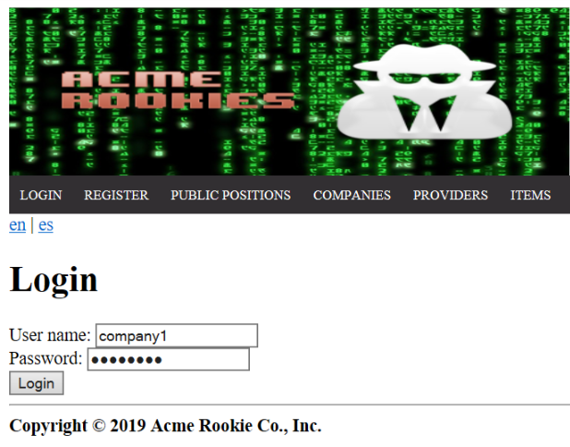

*Login as “company1/company1” > Header Menu > Display the "Company" options > My Positions*

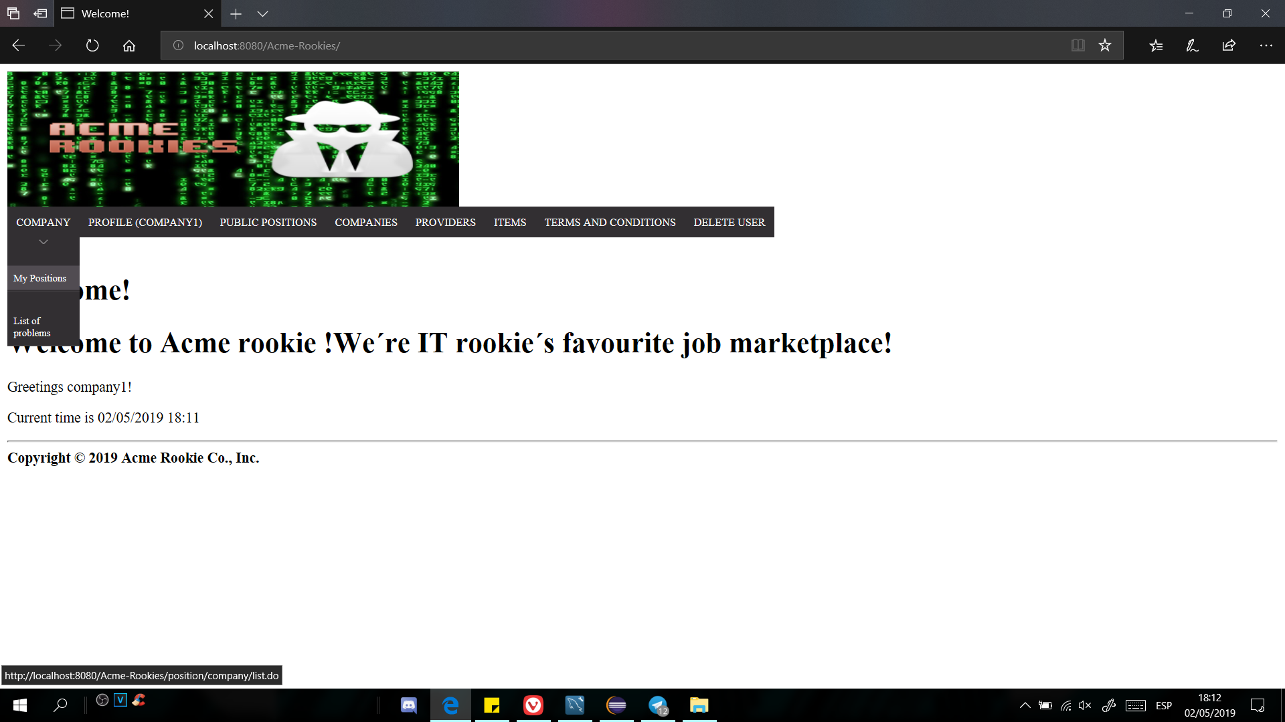

*After clicking on "My Positions", we should see the list of the positions.*

Tests

|  |  |
| --- | --- |
| Test 1 | |
| **Description** | *We must be able to see the list of positions from the logged company* |
| **Expected** | *In the list table there should be four positions and the columns "ticker, title, description, deadline, required profile, required skills, required technologies, offered salary, status, sponsorship, application, problems, audits and a las column just for edit or cancel" should appear.* |
| **Outcome** |  |
| **Notes** |  |

|  |  |
| --- | --- |
| Test 2 | |
| **Description** | *We must be able to see the skills list of the 4th position.* |
| **Expected** | *In the skill list the must be 2 elements called: Skill6 and Skill7* |
| **Outcome** |  |
| **Notes** |  |

|  |  |
| --- | --- |
| Test 3 | |
| **Description** | *After the Test2, the link “Back to your positions” should works well.* |
| **Expected** | *The web page should redirect you to the position list* |
| **Outcome** |  |
| **Notes** |  |

|  |  |
| --- | --- |
| Test 4 | |
| **Description** | *The system is available in two languages, so it must work correctly in both cases.* |
| **Expected** | *Changing the language, the expected results must be obtained in all the tests indicated above.* |
| **Outcome** |  |
| **Notes** |  |

# Use case UC20: Logged as company, create position

Description

An user logged in as a company can create positions.

Access

*Homepage > Header Menu > Login*

**

*Login as “company1/company1” > Header Menu > Display the "Company" options > My Positions*

**

*After clicking on "My Positions", we should see the list of the positions.*

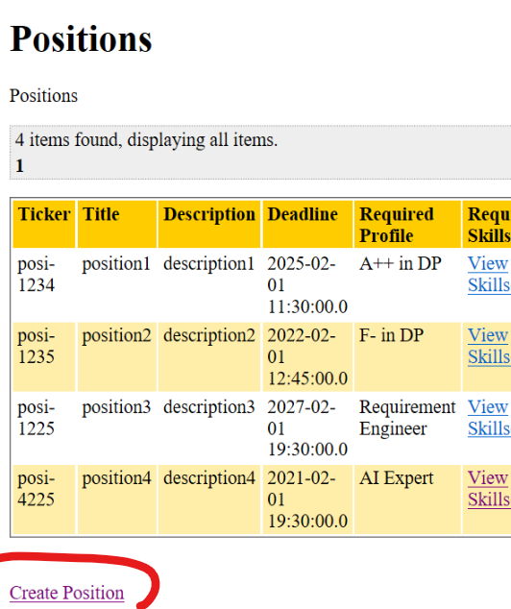

Finally, we must click on “Create Position” link and we should be the form position.

Tests

|  |  |
| --- | --- |
| Test 1 | |
| **Description** | *For instance, the form must be filled in with the following data:*  *Title: “Example’’,*  *Description: ‘Example Description’,*  *DeadLine: “16/07/2019 16:00”,*  *Drafmode*  *Required Profile: “Example”.*  *Required Skill: “Example”.*  *Required Technologies: “Example”*  *Offered Salary: 1*  *And select the 2 first problems* |
| **Expected** | *The system must redirect you to the position list and also, at the end of the list, will be this new position.* |
| **Outcome** |  |
| **Notes** | *Can be added some required skills and technologies by writing a comma between every element* |

|  |  |
| --- | --- |
| Test 2 | |
| **Description** | *For instance, the form must be filled in with the following data:*  *Title: “Example’’,*  *Description: ‘Example Description’,*  *DeadLine: “16/07/2019 16:00”,*  *Final Mode*  *Required Profile: “Example”.*  *Required Skill: “Example”.*  *Required Technologies: “Example”*  *Offered Salary: 1*  *And select the only 1 problem* |
| **Expected** | *The system must says that*  *“****You must select at least 2 problems if you save the position in final mode****”* |
| **Outcome** |  |
| **Notes** | *Can be added some required skills and technologies by writing a comma between every element* |

|  |  |
| --- | --- |
| Test 3 | |
| **Description** | *The system is available in two languages, so it must work correctly in both cases.* |
| **Expected** | *Changing the language, the expected results must be obtained in all the tests indicated above.* |
| **Outcome** |  |
| **Notes** |  |

# Use case UC21: Logged as company, edit or delete a position

Description

An user logged in as a company can edit or delete any position that is in draft mode.

Access

*Homepage > Header Menu > Login*

**

*Login as “company1/company1” > Header Menu > Display the "Company" options > My Positions*

**

*After clicking on "My Positions", we should see the list of the positions. Finally we should see the “Edit” link in the third position.*

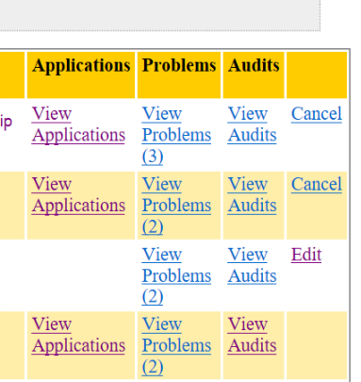

Tests

|  |  |
| --- | --- |
| Test 1 | |
| **Description** | *You should not be able to edit a canceled position. So in this case you can access to the edit view of the third position and change Id to next one (Ex: 279 to 280)* |
| **Expected** | *The system must redirect you to the position list.* |
| **Outcome** |  |
| **Notes** |  |

|  |  |
| --- | --- |
| Test 2 | |
| **Description** | *You should be able to cancel the first position, that has an application in submitted* |
| **Expected** | *When you cancel a position and there are Submitted applications there must be updated automatically to Rejected status, so the applications must be in Rejected status* |
| **Outcome** |  |
| **Notes** |  |

|  |  |
| --- | --- |
| Test 3 | |
| **Description** | *You should be able to delete the third position, that is in draft mode. You must go to the edit view:* |
| **Expected** | *The web page must redirect you at the position list and there must be one less element.* |
| **Outcome** |  |
| **Notes** |  |

|  |  |
| --- | --- |
| Test 4 | |
| **Description** | *The system is available in two languages, so it must work correctly in both cases.* |
| **Expected** | *Changing the language, the expected results must be obtained in all the tests indicated above.* |
| **Outcome** |  |
| **Notes** |  |

# Use case UC22: Logged as company, listing and showing his or her problems

Description

An user logged in as a company can see his or her problem list.

Access

*Homepage > Header Menu > Login*

**

*Login as “company1/company1” > Header Menu > Display the "Company" options > List of problems*

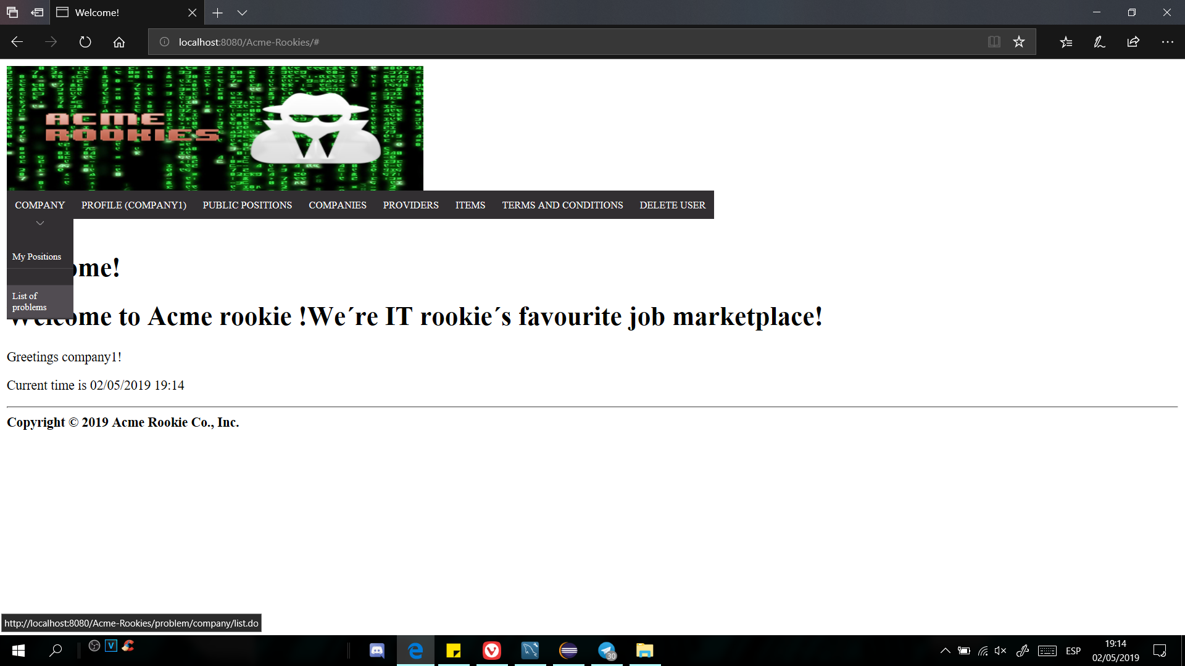

Then, you should see the problems list.

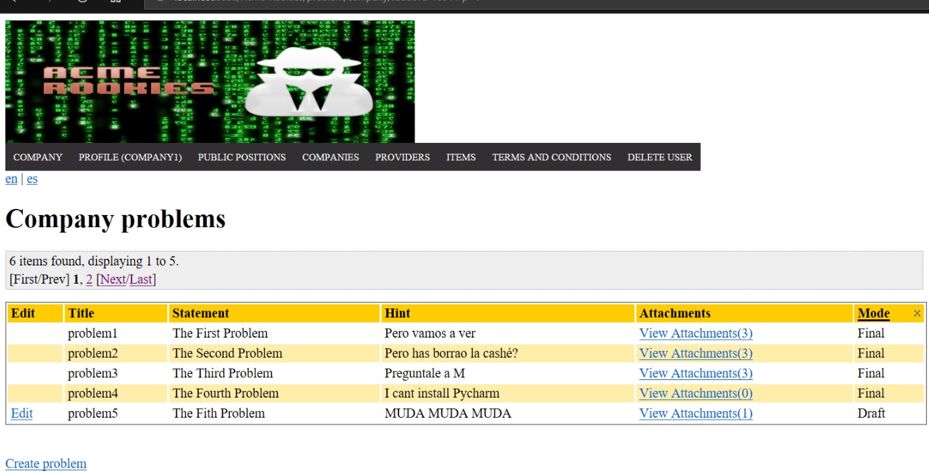

Tests

|  |  |
| --- | --- |
| Test 1 | |
| **Description** | *We should be able to see the problems list of the logged company.* |
| **Expected** | *There must be 7 columns:* |
| **Outcome** |  |
| **Notes** |  |

|  |  |
| --- | --- |
| Test 2 | |
| **Description** | *We should be able to see the every problem’s attachments list. For example we should see the 3 attachments of the first problem.* |
| **Expected** | *The view should show us 3 attachments* |
| **Outcome** |  |
| **Notes** |  |

|  |  |
| --- | --- |
| Test 3 | |
| **Description** | *The system is available in two languages, so it must work correctly in both cases.* |
| **Expected** | *Changing the language, the expected results must be obtained in all the tests indicated above.* |
| **Outcome** |  |
| **Notes** |  |

# Use case UC23: Logged as company, create a problem

Description

An user logged in as a company can create a problem.

Access

*Homepage > Header Menu > Login*

**

*Login as “company1/company1” > Header Menu > Display the "Company" options > List of problems*



Then, you should see the problems list.



Finally, you must click on the “Create Problem” link at bottom.

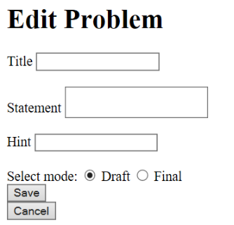

Tests

|  |  |
| --- | --- |
| Test 1 | |
| **Description** | *For instance, the form must be filled in with the following data:*  *Title: Example*  *Statement:Example*  *Hint: Example*  *SelectMode: Draft* |
| **Expected** | *The system must redirect you to the item list and also, at the end of the list, will appear this new problem:* |
| **Outcome** |  |
| **Notes** |  |

|  |  |
| --- | --- |
| Test 2 | |
| **Description** | *For instance, the form must be filled in with the following data (All blank):*  *Title:*  *Statement:*  *Hint:*  *SelectMode:* |
| **Expected** | *The system must redirect you at the same view saying that the Title and the Statement must not be blank* |
| **Outcome** |  |
| **Notes** |  |

|  |  |
| --- | --- |
| Test 3 | |
| **Description** | *If you enter in the create view, you should be able to cancel the action by clicking on the “Cancel” button* |
| **Expected** | *The system must redirect you at the problems list* |
| **Outcome** |  |
| **Notes** |  |

|  |  |
| --- | --- |
| Test 4 | |
| **Description** | *The system is available in two languages, so it must work correctly in both cases.* |
| **Expected** | *Changing the language, the expected results must be obtained in all the tests indicated above.* |
| **Outcome** |  |
| **Notes** |  |

# Use case UC24: Logged as company, edit or delete a problem

Description

An user logged in as a company can edit or delete a problem that is in final mode.

Access

*Homepage > Header Menu > Login*

**

*Login as “company1/company1” > Header Menu > Display the "Company" options > List of problems*



Then, you should see the problems list.



Finally, you must click on the “Edit” link, on the right of every row.

Tests

|  |  |
| --- | --- |
| Test 1 | |
| **Description** | *You will try to change the Id in order to try edit a problem that is in final mode. You can access to the edit view of the 5th problem and decrement by one the Id (Ex: 296 to 295).* |
| **Expected** | *The system must redirect you to the problem list.* |
| **Outcome** |  |
| **Notes** |  |

|  |  |
| --- | --- |
| Test 2 | |
| **Description** | *For instance, we click on the “edit” link of the 5th row, and change the title to: “Edit Problem’’,* |
| **Expected** | *The system must redirect you to the problem list and you will see the 5th problem with the new title.* |
| **Outcome** |  |
| **Notes** |  |

|  |  |
| --- | --- |
| Test 3 | |
| **Description** | *For instance, we click on the “edit” link of the 5th row, and click to delete button in order to delete it.* |
| **Expected** | *The system must redirect you to the problem list and you will see that there is one less element.* |
| **Outcome** |  |
| **Notes** |  |

|  |  |
| --- | --- |
| Test 4 | |
| **Description** | *The system is available in two languages, so it must work correctly in both cases.* |
| **Expected** | *Changing the language, the expected results must be obtained in all the tests indicated above.* |
| **Outcome** |  |
| **Notes** |  |

# Use case UC25: Logged as company, list the position’s applications.

Description

An user logged in as a company can list the applications of every position.

Access

*Homepage > Header Menu > Login*

**

*Login as “company1/company1” > Header Menu > Display the "Company" options > My Positions*

**

*After clicking on "My Positions", we should see the list of the positions. Finally we should see the “View Applications” link in the applications that are in final mode.*



Tests

|  |  |
| --- | --- |
| Test 1 | |
| **Description** | *We should be able to see all the information abouts the applications* |
| **Expected** | *There must be this 9 columns:* |
| **Outcome** |  |
| **Notes** |  |

|  |  |
| --- | --- |
| Test 2 | |
| **Description** | *We should be able to see the rookie’s curriculums of every application, by clicking on the “View Curriculum” link.* |
| **Expected** | *There must be the following information:* |
| **Outcome** |  |
| **Notes** |  |

|  |  |
| --- | --- |
| Test 3 | |
| **Description** | *The system is available in two languages, so it must work correctly in both cases.* |
| **Expected** | *Changing the language, the expected results must be obtained in all the tests indicated above.* |
| **Outcome** |  |
| **Notes** |  |

# Use case UC26: Logged as company, change the status of an application

Description

An user logged in as a company can change the status of the submitted applications to Rejected or Accepted.

Access

*Homepage > Header Menu > Login*

**

*Login as “company1/company1” > Header Menu > Display the "Company" options > My Positions*

**

*After clicking on "My Positions", we should see the list of the positions.*



*After clicking on “View Applications” we should be able to see the “Accept” or “Reject” options*

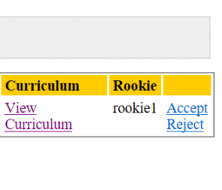

Tests

|  |  |
| --- | --- |
| Test 1 | |
| **Description** | *We should be able to “Accept” the application of the*  *First position.* |
| **Expected** | *After clicking on the “Accept” button, the web page must redirect us to the position list, and he application status should be “Accepted”.* |
| **Outcome** |  |
| **Notes** |  |

|  |  |
| --- | --- |
| Test 2 | |
| **Description** | *The Accepted or Rejected applications status can’t be changed.* |
| **Expected** | *After clicking on the “Accept” button, the web page must redirect us to the position list, and he application status should be “Accepted”.* |
| **Outcome** |  |
| **Notes** |  |

|  |  |
| --- | --- |
| Test 3 | |
| **Description** | *The system is available in two languages, so it must work correctly in both cases.* |
| **Expected** | *Changing the language, the expected results must be obtained in all the tests indicated above.* |
| **Outcome** |  |
| **Notes** |  |

# Use case UC27: Authenticated as any role or not, browse the list of providers and navigate to their items.

Description

An user logged in as any role or an anonymous user can browse the list of providers.

Access

*Homepage > Header Menu > Providers*

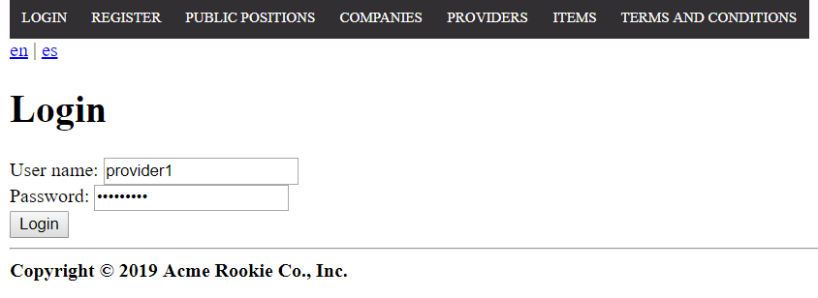

Tests

|  |  |
| --- | --- |
| Test 1 | |
| **Description** | *We must be able to see the list of providers and their data.* |
| **Expected** | *In the list table there should be the next five providers of the system (the table shows the first page with five providers, but there are ten in total) and the columns “make, name, vat number, photo, email, phone, address and items” should appear. Above the table, the pagination box should be displayed.* |
| **Outcome** |  |
| **Notes** | *The expected results are based on the populate data.* |

|  |  |
| --- | --- |
| Test 2 | |
| **Description** | *“View items” links must work correctly.* |
| **Expected** | *If we click on “View items” in “the master provider” row of the table we should see the next.* |
| **Outcome** |  |
| **Notes** | *The expected results are based on the populate data.* |

|  |  |
| --- | --- |
| Test 3 | |
| **Description** | *We must be able to sort the first seven columns.* |
| **Expected** | *The first seven columns of the table must be sortables by the user and this functionality must work correctly.* |
| **Outcome** |  |
| **Notes** | *The expected results are based on the populate data.* |

|  |  |
| --- | --- |
| Test 4 | |
| **Description** | *We must be able to access the different pages of the table. Only five providers per page are shown.* |
| **Expected** | *At the top of the table, if we click on “last”, the system must show us the last page of providers.* |
| **Outcome** |  |
| **Notes** | *The expected results are based on the populate data.* |

|  |  |
| --- | --- |
| Test 5 | |
| **Description** | *We must not be able to see the “items” of a provider that doesn’t exist in the system.* |
| **Expected** | *If we try to see the “items” of a provider with id (99999), using the url: /anonymous/item/list.do?providerId=99999, the page will say “nothing found to display”.* |
| **Outcome** |  |
| **Notes** | *The expected results are based on the populate data.* |

|  |  |
| --- | --- |
| Test 6 | |
| **Description** | *The system is available in two languages, so it must work correctly in both cases.* |
| **Expected** | *Changing the language, the expected results must be obtained in all the tests indicated above.* |
| **Outcome** |  |
| **Notes** | *The expected results are based on the populate data.* |

# Use case UC28: Authenticated as any role or not, browse the list of items and navigate to their providers.

Description

An user logged in as any role or an anonymous user can browse the list of items.

Access

*Homepage > Header Menu > Items*

**

Tests

|  |  |
| --- | --- |
| Test 1 | |
| **Description** | *We must be able to see the list of items and their data.* |
| **Expected** | *In the list table there should be five items (all items of the system) and the columns “name, description, links, pictures and provider” should appear. Above the table, the pagination box should be displayed.* |
| **Outcome** |  |
| **Notes** | *The expected results are based on the populate data.* |

|  |  |
| --- | --- |
| Test 2 | |
| **Description** | *“View the Provider profile” links must work correctly.* |
| **Expected** | *If we click on “View the Provider profile” in “Dreamviewer” row of the table we should see the next and the back button must work.* |
| **Outcome** |  |
| **Notes** | *The expected results are based on the populate data.* |

|  |  |
| --- | --- |
| Test 3 | |
| **Description** | *We must be able to sort the first two columns.* |
| **Expected** | *The first two columns of the table must be sortables by the user and this functionality must work correctly.* |
| **Outcome** |  |
| **Notes** | *The expected results are based on the populate data.* |

|  |  |
| --- | --- |
| Test 4 | |
| **Description** | *We must be able to access the different pages of the table. Only five items per page are shown.* |
| **Expected** | *At the top of the table, if we click on “last”, the system must show us the last page of items with one item.* |
| **Outcome** |  |
| **Notes** | *The expected results are based on the populate data.* |

|  |  |
| --- | --- |
| Test 5 | |
| **Description** | *We must be able to see the number of pictures or links of the item.* |
| **Expected** | *In the links to watch the "links" or the "pictures" should appear a number in parentheses, which is the number of elements.* |
| **Outcome** |  |
| **Notes** | *The expected results are based on the populate data.* |

|  |  |
| --- | --- |
| Test 6 | |
| **Description** | *We must be able to see the “pictures” and “links” clicking in the corresponding link.* |
| **Expected** | *If we click in “View pictures” and “View links” on “PyCharm” row, the system will redirect us to a page with a table which has one column. The content of the table will be the “pictures” or “links” depending on where we click, and the buttons must work.* |
| **Outcome** |  |
| **Notes** | *The expected results are based on the populate data.* |

|  |  |
| --- | --- |
| Test 7 | |
| **Description** | *The system is available in two languages, so it must work correctly in both cases.* |
| **Expected** | *Changing the language, the expected results must be obtained in all the tests indicated above.* |
| **Outcome** |  |
| **Notes** | *The expected results are based on the populate data.* |

# Use case UC29: Not authenticated, register to the system as a provider.

Description

An anonymous user can register to the system as a provider.

Access

*Homepage > Header Menu > Register > Register as provider*

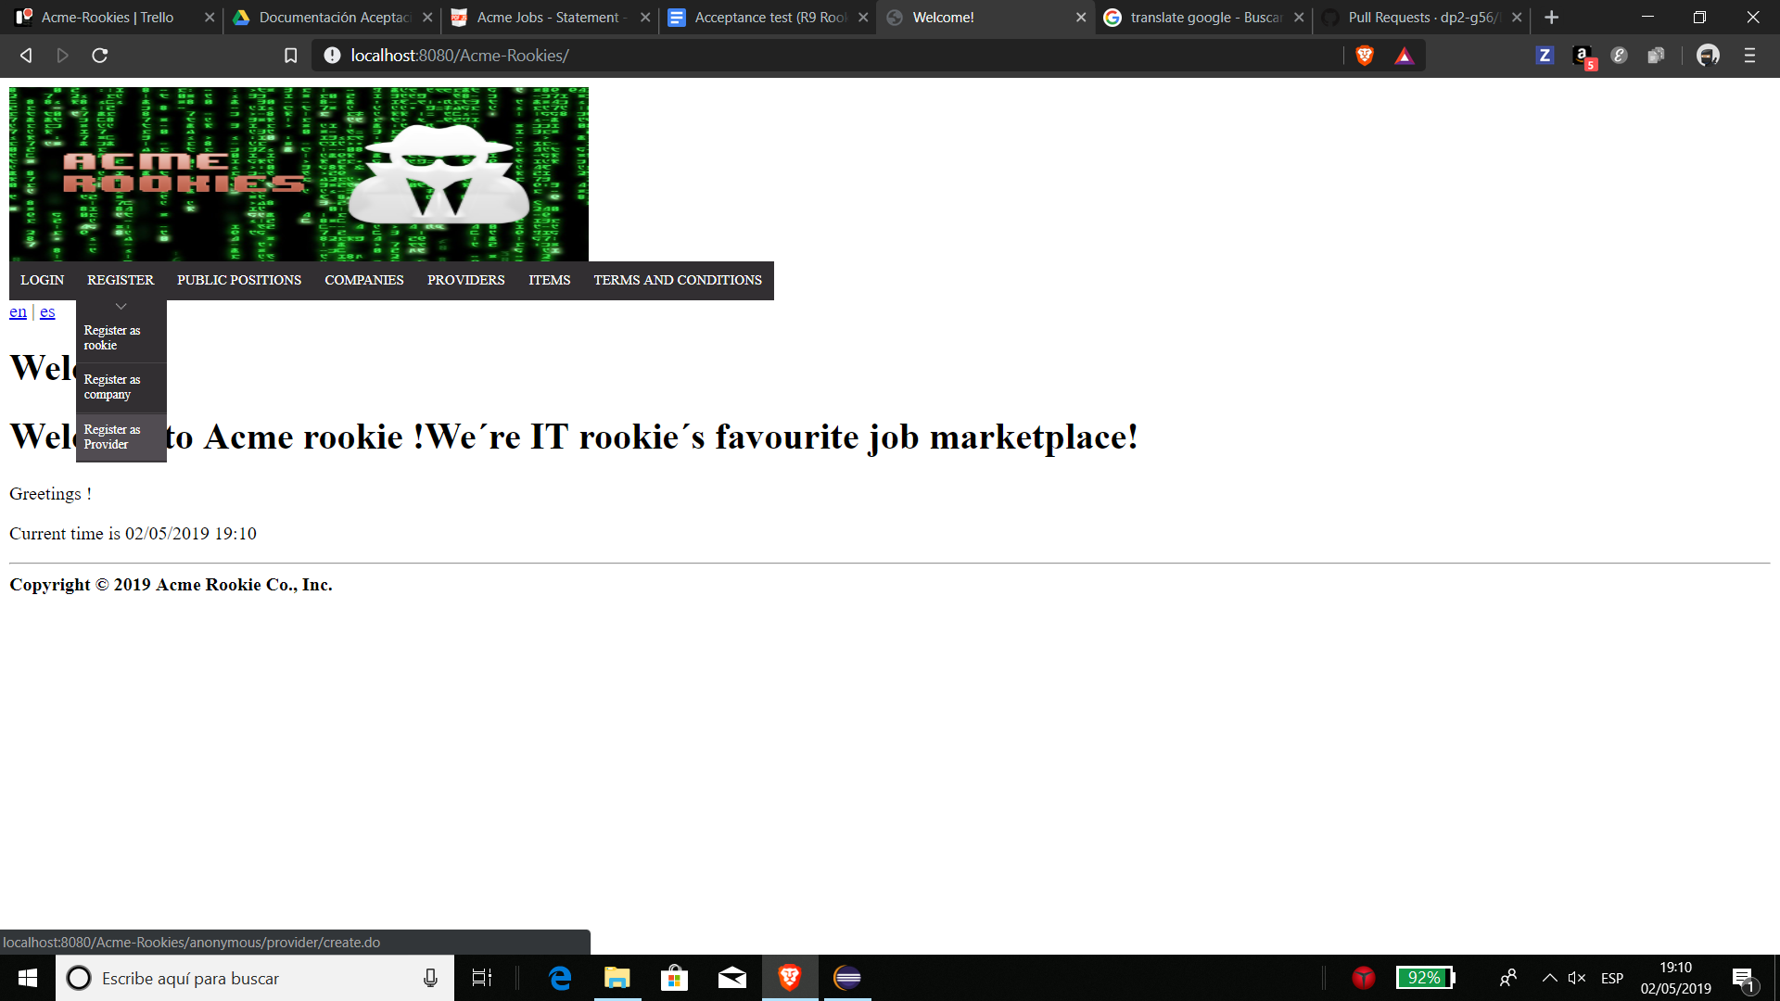

Tests

|  |  |
| --- | --- |
| Test 1 | |
| **Description** | *We must be able to see the form to register as a provider in the system.* |
| **Expected** | *The form must contains the fields “username, password, confirm password, make, name, surnames, vat number, photo, email, phone number, address, holder name, brand name, number, expiration month, expiration year, cvv code” and the checkbox to confirm the “terms and conditions”.* |
| **Outcome** |  |
| **Notes** | *The expected results are based on the populate data.* |

|  |  |
| --- | --- |
| Test 2 | |
| **Description** | *An anonymous user can register as a provider introducing valid data in the form.* |
| **Expected** | *Introducing the next information (“password” and “confirm password” as “provider”):*    *After clicking on save, the system will redirect us to the home page and now we can log in with the user “provider/provider”.* |
| **Outcome** |  |
| **Notes** | *The expected results are based on the populate data.* |

|  |  |
| --- | --- |
| Test 3 | |
| **Description** | *An anonymous user can regress to the home page using the “cancel” button.* |
| **Expected** | *If we click on the the cancel “button”, the system will redirect us to the home page.* |
| **Outcome** |  |
| **Notes** | *The expected results are based on the populate data.* |

|  |  |
| --- | --- |
| Test 4 | |
| **Description** | *An anonymous user tries to register as a provider leaving all fields blank.* |
| **Expected** | *After clicking on save, the system will ask us for a confirmation to save the phone as blank, and we will see the next error messages.* |
| **Outcome** |  |
| **Notes** | *The expected results are based on the populate data.* |

|  |  |
| --- | --- |
| Test 5 | |
| **Description** | *The user can read the “terms and conditions” before accepting them.* |
| **Expected** | *If the user clicks on “terms and conditions” at the end of the form,*    *the system will redirect us to a page in another windows to read them.* |
| **Outcome** |  |
| **Notes** | *The expected results are based on the populate data.* |

|  |  |
| --- | --- |
| Test 6 | |
| **Description** | *An anonymous user tries to register as a provider introducing valid data in the form, but the passwords doesn’t match.* |
| **Expected** | *Introducing the information indicated in the test 2, the password as “provider” and “confirm password” as “probider”, after clicking on save the system will show us the next error.* |
| **Outcome** |  |
| **Notes** | *The expected results are based on the populate data.* |

|  |  |
| --- | --- |
| Test 7 | |
| **Description** | *An anonymous user tries to register as a provider introducing valid data in the form, but the terms and conditions have not been accepted.* |
| **Expected** | *Introducing the information indicated in the test 2, the “password” and “confirm password” as “provider”, and leaving unmarked the terms and conditions, after clicking on save the system will show us the next error.* |
| **Outcome** |  |
| **Notes** | *The expected results are based on the populate data.* |

|  |  |
| --- | --- |
| Test 8 | |
| **Description** | *An anonymous user tries to register as a provider introducing valid data in the form, but the credit card data is incorrect.* |
| **Expected** | *Introducing the information indicated in the test 2, the “password” and “confirm password” as “provider”, the “number” as “4943227714203015”, the “expiration month” as “12” and the “expiration year” as 18”, after clicking on save the system will show us the next error.* |
| **Outcome** |  |
| **Notes** | *The expected results are based on the populate data.* |

|  |  |
| --- | --- |
| Test 9 | |
| **Description** | *An anonymous user tries to register as a provider introducing valid data in the form, but the vat number is incorrect.* |
| **Expected** | *Introducing the information indicated in the test 2, the “password” and “confirm password” as “provider” and the “vat number” as “ES12”, after clicking on save the system will show us the next error.* |
| **Outcome** |  |
| **Notes** | *The expected results are based on the populate data.* |

|  |  |
| --- | --- |
| Test 10 | |
| **Description** | *An anonymous user registers as a provider introducing valid data in the form introducing an* XSS or SQL sentence in the make field. |
| **Expected** | *Introducing the information indicated in the test 2, the “password” and “confirm password” as “provider” and the “make” as “<script>alarm('Hacker!');</script>”, after clicking on save the system will register the new user but the* content of the sentence won’t affect the database because SQL Injections have been prevented. |
| **Outcome** |  |
| **Notes** | *The expected results are based on the populate data.* |

|  |  |
| --- | --- |
| Test 11 | |
| **Description** | *The system is available in two languages, so it must work correctly in both cases.* |
| **Expected** | *Changing the language, the expected results must be obtained in all the tests indicated above.* |
| **Outcome** |  |
| **Notes** | *The expected results are based on the populate data.* |

# Use case UC30: Logged as rookie, list and filter his or her applications

Description

An user logged in as a rookie can list and filter his or her applications.

Access

*Homepage > Header Menu > Login*

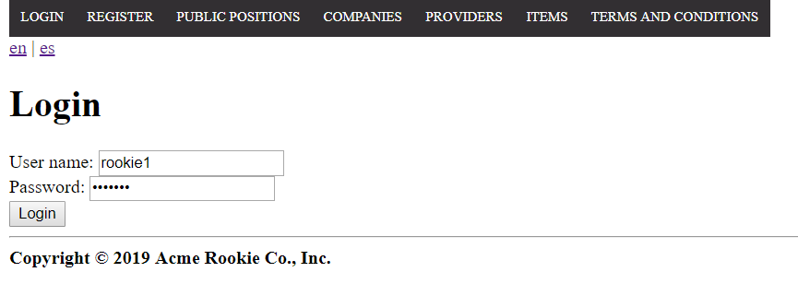

*Login as “rookie1/rookie1” > Header Menu > Display the "Rookie" options > My applications*

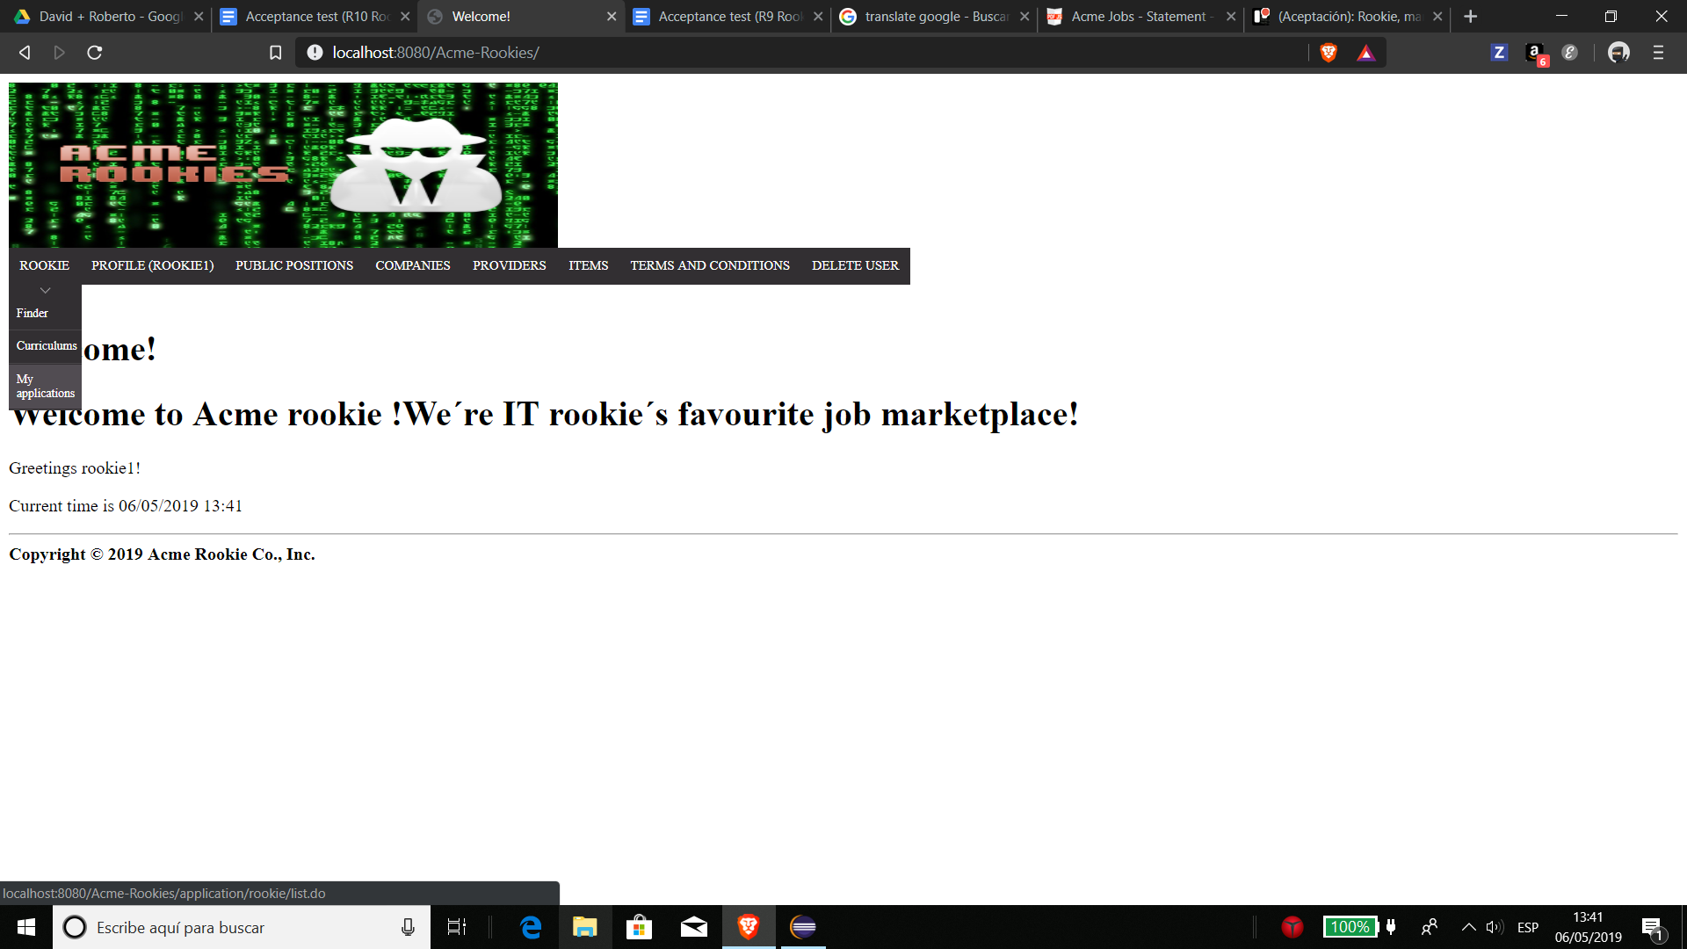

*After clicking on "My applications", we should see the list of the applications.*

Tests

|  |  |
| --- | --- |
| Test 1 | |
| **Description** | *We must be able to see the list of applications that the rookie with whom we have logged in has.* |
| **Expected** | *In the list table there should be the next two items and the following columns with this concrete information and links. Above the table, the pagination box and the form to filter the applications should be displayed, and at the bottom the link to create a new application should be displayed too.* |
| **Outcome** |  |
| **Notes** | *The expected results are based on the populate data.* |

|  |  |
| --- | --- |
| Test 2 | |
| **Description** | *We must be able to sort the first column.* |
| **Expected** | *The first column of the table must be sortable by the user and this functionality must work correctly.* |
| **Outcome** |  |
| **Notes** | *The expected results are based on the populate data.* |

|  |  |
| --- | --- |
| Test 3 | |
| **Description** | *We must be able to filter the applications according to their status.* |
| **Expected** | *If we select “pending” in the filter field and click on the filter button,*    *the system will reload the page and show us one application.* |
| **Outcome** |  |
| **Notes** | *The expected results are based on the populate data.* |

|  |  |
| --- | --- |
| Test 4 | |
| **Description** | *“Edit application” link and “create an application” button must work correctly.* |
| **Expected** | *If we click on “edit application” in the “problem 3” row or press in “create an application” we should see the next and the cancel buttons must work.* |
| **Outcome** |  |
| **Notes** | *The expected results are based on the populate data.* |

|  |  |
| --- | --- |
| Test 5 | |
| **Description** | *We must not be able to edit an application that is not in “pending” status or an application that does not belong to the logged rookie.* |
| **Expected** | *The application that corresponds to “problem3” should not show the edit link in the last column of the table, and also, if we try to edit an application with id “99999” using the url “/application/rookie/edit.do?applicationId=99999”, the system will redirect us to the list of applications.* |
| **Outcome** |  |
| **Notes** | *The expected results are based on the populate data.* |

|  |  |
| --- | --- |
| Test 6 | |
| **Description** | *The system is available in two languages, so it must work correctly in both cases.* |
| **Expected** | *Changing the language, the expected results must be obtained in all the tests indicated above.* |
| **Outcome** |  |
| **Notes** | *The expected results are based on the populate data.* |

# Use case UC31: Logged as rookie, create an application

Description

An user logged in as a rookie can apply for a position.

Access

*Homepage > Header Menu > Login*

**

*Login as “rookie1/rookie1” > Header Menu > Display the "Rookie" options > My applications*

**

*After clicking on "My applications", we should see the list of the applications.*

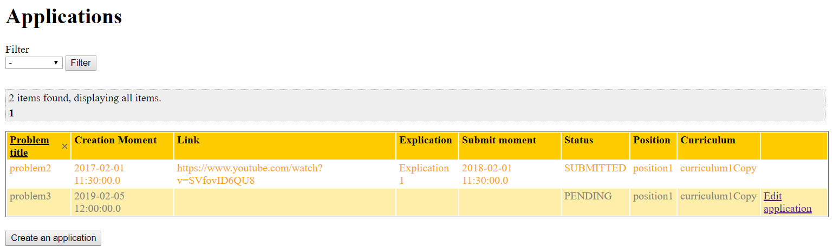

*Now we have to press the “create an application” button.*

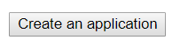

Tests

|  |  |
| --- | --- |
| Test 1 | |
| **Description** | *We must be able to see the form to create an application.* |
| **Expected** | *The form must contains the fields “curriculum” and “position”.* |
| **Outcome** |  |
| **Notes** | *The expected results are based on the populate data.* |

|  |  |
| --- | --- |
| Test 2 | |
| **Description** | *A rookie can apply for a position.* |
| **Expected** | *Selecting the following in the form:*    *After clicking on save, the system will redirect us to the list of rookie applications and the new application will appear.*    *The curriculum is a copy of the original one. You can check that deleting the “curriculum1”.* |
| **Outcome** |  |
| **Notes** | *The expected results are based on the populate data.* |

|  |  |
| --- | --- |
| Test 3 | |
| **Description** | *An anonymous user can regress to the list of rookie applications using the “cancel” button.* |
| **Expected** | *If we click on the the cancel “button”, the system will redirect us to the list of rookie applications.* |
| **Outcome** |  |
| **Notes** | *The expected results are based on the populate data.* |

|  |  |
| --- | --- |
| Test 4 | |
| **Description** | *The system is available in two languages, so it must work correctly in both cases.* |
| **Expected** | *Changing the language, the expected results must be obtained in all the tests indicated above.* |
| **Outcome** |  |
| **Notes** | *The expected results are based on the populate data.* |

# Use case UC32: Logged as rookie, update an application

Description

An user logged in as a rookie can update an application.

Access

*Homepage > Header Menu > Login*

**

*Login as “rookie1/rookie1” > Header Menu > Display the "Rookie" options > My applications*

**

*After clicking on "My applications", we should see the list of the applications.*



*Now we have to click on the “edit application” link in the “problem3” application row.*

# 

Tests

|  |  |
| --- | --- |
| Test 1 | |
| **Description** | *We must be able to see the form to update an application.* |
| **Expected** | *The form must contains the fields “explication” and “link”.* |
| **Outcome** |  |
| **Notes** | *The expected results are based on the populate data.* |

|  |  |
| --- | --- |
| Test 2 | |
| **Description** | *A rookie can update an application introducing correct data.* |
| **Expected** | *Introducing the next in the form:*    *After clicking on edit, the system will redirect us to the list of rookie applications and the application will appear with the completed "explanation" and "link" fields and the status will have been submitted.* |
| **Outcome** |  |
| **Notes** | *The expected results are based on the populate data.* |

|  |  |
| --- | --- |
| Test 3 | |
| **Description** | *A rookie can regress to the list of rookie applications using the “cancel” button.* |
| **Expected** | *If we click on the the cancel “button”, the system will redirect us to the list of rookie applications.* |
| **Outcome** |  |
| **Notes** | *The expected results are based on the populate data.* |

|  |  |
| --- | --- |
| Test 4 | |
| **Description** | *A rookie tries to update an application leaving all fields blank.* |
| **Expected** | *The explication is mandatory, but the link is optional. After clicking on edit, we will see the next error message.* |
| **Outcome** |  |
| **Notes** | *The expected results are based on the populate data.* |

|  |  |
| --- | --- |
| Test 5 | |
| **Description** | *A rookie can update an application leaving the “link” field in blank.* |
| **Expected** | *Introducing the next in the form:*    *After clicking on edit, the system will redirect us to the list of rookie applications and the application will appear with the completed "explanation" field and the status will have changed to submitted.* |
| **Outcome** |  |
| **Notes** | *The expected results are based on the populate data.* |

|  |  |
| --- | --- |
| Test 6 | |
| **Description** | *A rookie tries to update an application introducing an* XSS or SQL sentence in the explication field. |
| **Expected** | *Introducing “<script>alarm('Hacker!');</script>” in “explication” field,*    *after clicking on edit the system update the explication but the* content of the sentence won’t affect the database because SQL Injections have been prevented. |
| **Outcome** |  |
| **Notes** | *The expected results are based on the populate data.* |

|  |  |
| --- | --- |
| Test 7 | |
| **Description** | *A rookie can not update an application that does not belong to him or her, or an application that doesn’t exist.* |
| **Expected** | *If we try to update an application with id “99999”, using the url “/Acme-Rookies/application/rookie/edit.do?applicationId=99999” the system will redirect us to the list of rookie applications.* |
| **Outcome** |  |
| **Notes** | *The expected results are based on the populate data.* |

|  |  |
| --- | --- |
| Test 8 | |
| **Description** | *The system is available in two languages, so it must work correctly in both cases.* |
| **Expected** | *Changing the language, the expected results must be obtained in all the tests indicated above.* |
| **Outcome** |  |
| **Notes** | *The expected results are based on the populate data.* |

# Use case UC33: Logged as provider, list and show his or her items

Description

An user logged in as a provider can list the items he or she has published.

Access

*Homepage > Header Menu > Login*

**

*Login as “provider1/provider1” > Header Menu > Display the "Provider" options > Items*

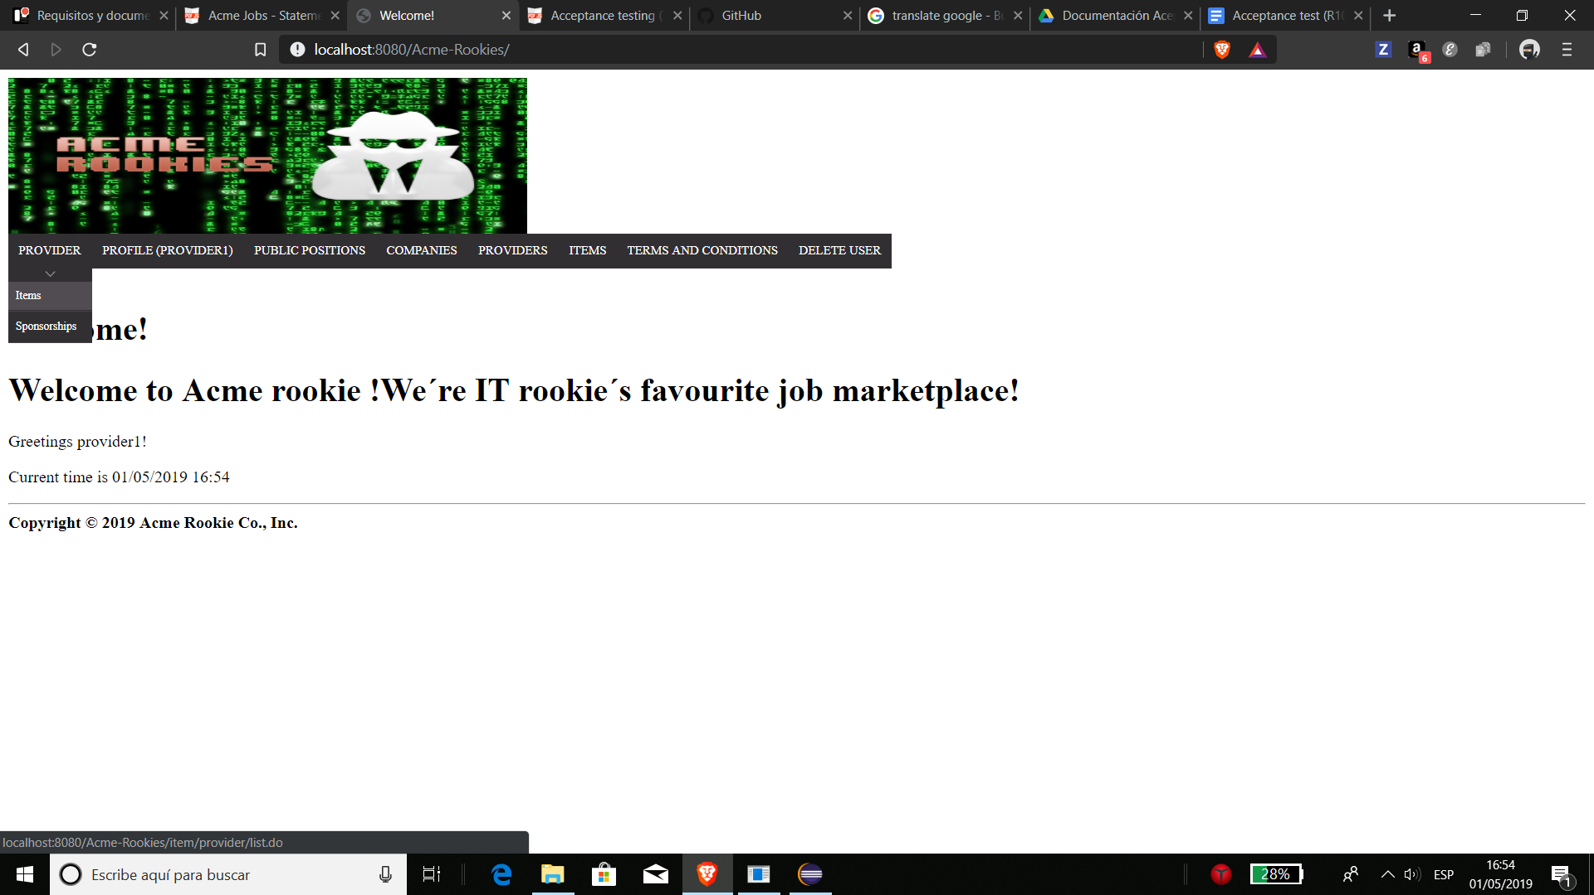

*After clicking on "items", we should see the list of the items.*

Tests

|  |  |
| --- | --- |
| Test 1 | |
| **Description** | *We must be able to see the list of items that the provider with whom we have logged in has.* |
| **Expected** | *In the list table there should be the next three items and the following columns with this concrete information and links. Above the table, the pagination box should be displayed, and at the bottom the link to create a new item should be displayed.* |
| **Outcome** |  |
| **Notes** | *The expected results are based on the populate data.* |

|  |  |
| --- | --- |
| Test 2 | |
| **Description** | *We must be able to sort the first two columns.* |
| **Expected** | *The first two columns of the table must be sortables by the user and this functionality must work correctly.* |
| **Outcome** |  |
| **Notes** | *The expected results are based on the populate data.* |

|  |  |
| --- | --- |
| Test 3 | |
| **Description** | *We must be able to see the number of pictures or links of the item.* |
| **Expected** | *In the links to watch the "links" or the "pictures" should appear a number in parentheses, which is the number of elements.* |
| **Outcome** |  |
| **Notes** | *The expected results are based on the populate data.* |

|  |  |
| --- | --- |
| Test 4 | |
| **Description** | *“New item” and “edit” links must work correctly.* |
| **Expected** | *If we click on “new item” or in “edit” in one row of the table we should see the next and the cancel buttons must work.* |
| **Outcome** |  |
| **Notes** | *The expected results are based on the populate data.* |

|  |  |
| --- | --- |
| Test 5 | |
| **Description** | *We must be able to see the “pictures” and “links” clicking in the corresponding link.* |
| **Expected** | *If we click in “View pictures” and “View links”, the system will redirect us to a page with a table which has one column. The content of the table will be the “pictures” or “links” depending on where we click, and the back buttons must redirect to the list of items.* |
| **Outcome** |  |
| **Notes** | *The expected results are based on the populate data.* |

|  |  |
| --- | --- |
| Test 6 | |
| **Description** | *We must not be able to see the “links” of “pictures” of an item that we have not published.* |
| **Expected** | *If we try to see the “links” and “pictures” of an item with id (99999), using the url: /item/provider/listLinks.do?itemId=99999 and /item/provider/listPictures.do?itemId=99999, the page will say “nothing found to display”.* |
| **Outcome** |  |
| **Notes** | *The expected results are based on the populate data.* |

|  |  |
| --- | --- |
| Test 7 | |
| **Description** | *The system is available in two languages, so it must work correctly in both cases.* |
| **Expected** | *Changing the language, the expected results must be obtained in all the tests indicated above.* |
| **Outcome** |  |
| **Notes** | *The expected results are based on the populate data.* |

# Use case UC34: Logged as provider, create an item

Description

An user logged as a provider can create items.

Access

*We suppose that the user is registered as provider, so he or she must loggin the webpage:*

**

*And select the “Items” options in the “Provider” Scroll.*

**

*Next he or she must click on the “New Item” button.*

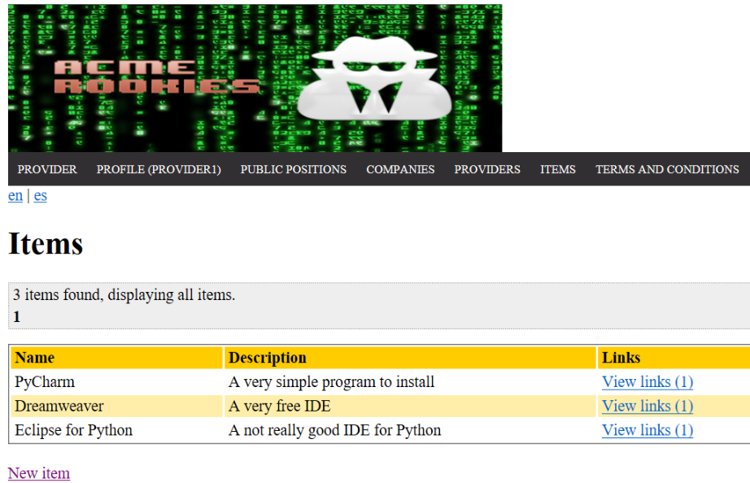

*Finally we got the interface that implement this use case.*

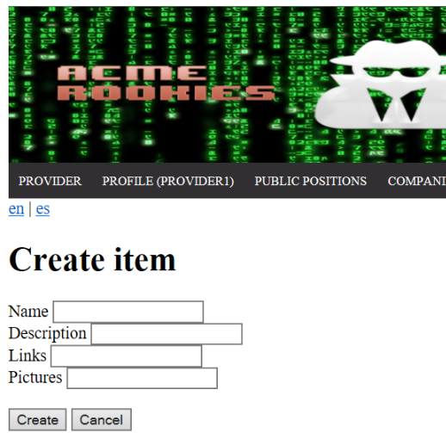

Tests

|  |  |
| --- | --- |
| Test 1 | |
| **Description** | *For instance, the form must be filled in with the following data:*  *Name: “Item test’’*  *Description: ‘Example Description’*  *Links: “https://trello.com,* [*https://trello.com*](https://trello.com)*”*  *Pictures: “https://www.pinterest.es,* [*https://www.pinterest.es*](https://www.pinterest.es)*”.* |
| **Expected** | *The system must redirect you to the item list and also, at the end of the list, will appear this new item with 2 pictures, 2 links, named ”Item test” with the description: “Example Description”.* |
| **Outcome** |  |
| **Notes** | *Can be added some pictures and links by putting a comma between every url* |

|  |  |
| --- | --- |
| Test 2 | |
| **Description** | *For instance, the form must be filled in with the following data:*  *Name: “Item test’’,*  *Description: ‘Example Description’,*  *Links: “example, example”,*  *Pictures: “https://www.pinterest.es, https://www.pinterest.es”.* |
| **Expected** | *The system must redirect you at the same view saying that the input links are wrongs urls.* |
| **Outcome** |  |
| **Notes** | *Can be added some pictures and links by putting a comma between every url* |

|  |  |
| --- | --- |
| Test 3 | |
| **Description** | *For instance, the form must be filled in with the following data: Name:“”, Description: “”, Links: “”, Pictures: “”.* |
| **Expected** | *The system must redirect you at the same view saying that name and description must not be blank.* |
| **Outcome** |  |
| **Notes** | *Can be added some pictures and links by putting a comma between every url* |

|  |  |
| --- | --- |
| Test 4 | |
| **Description** | *The system is available in two languages, so it must work correctly in both cases.* |
| **Expected** | *Changing the language, the expected results must be obtained in all the tests indicated above.* |
| **Outcome** |  |
| **Notes** |  |

# Use case UC35: Logged as provider, edit an item

Description

An user logged as a provider edit his or her items.

Access

*We suppose that the user is registered as provider, so he or she must loggin the webpage:*

**

*And select the “Items” options in the “Provider” Scroll.*

**

*Next we must to select the “Edit” link, on the right, in any row to access the edit interface:*

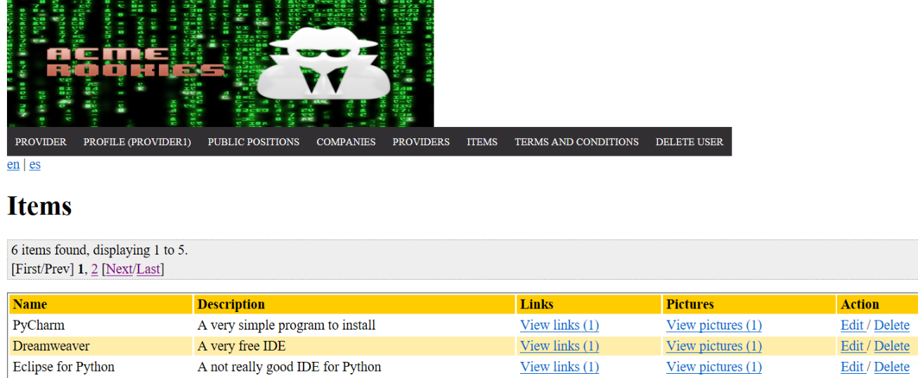

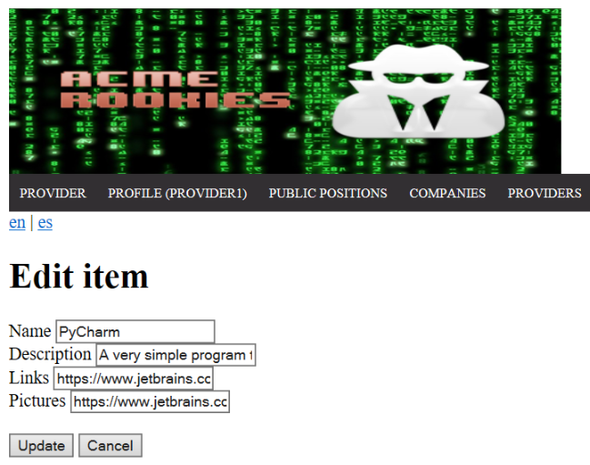

Tests

|  |  |
| --- | --- |
| Test 1 | |
| **Description** | *For instance, we click on the “edit” link of the first row, and change the name to: “Item Edit test’’,* |
| **Expected** | *The system must redirect you to the item list and, at the begging of the list, will be the same item with only the Name changed.* |
| **Outcome** |  |
| **Notes** | *Can be added some pictures and links by putting a comma between every url* |

|  |  |
| --- | --- |
| Test 2 | |
| **Description** | *For instance, we click on the “edit” link of the third row and change the url write the next id number (If the Id is 377 we must write 378).* |
| **Expected** | *The system must redirect you to the index.* |
| **Outcome** |  |
| **Notes** | *The idea of this is test is that you can’t edit an item that you don’t own.* |

|  |  |
| --- | --- |
| Test 3 | |
| **Description** | *For instance, we click on the “edit” link of the first row, and change the links input to: “’’,* |
| **Expected** | *The system must redirect you to the item list and, at the begging of the list, will be the same item with no links. (View Links (0) )* |
| **Outcome** |  |
| **Notes** | *Can be added some pictures and links by putting a comma between every url* |

|  |  |
| --- | --- |
| Test 4 | |
| **Description** | *The system is available in two languages, so it must work correctly in both cases.* |
| **Expected** | *Changing the language, the expected results must be obtained in all the tests indicated above.* |
| **Outcome** |  |
| **Notes** |  |

# Use case UC36: Logged as provider, delete an item

Description

An user logged in as a provider can delete the items he or she has published.

Access

*Homepage > Header Menu > Login*

**

*Login as “provider1/provider1” > Header Menu > Display the "Provider" options > Items*

**

*After clicking on "items", we should see the list of the items.*

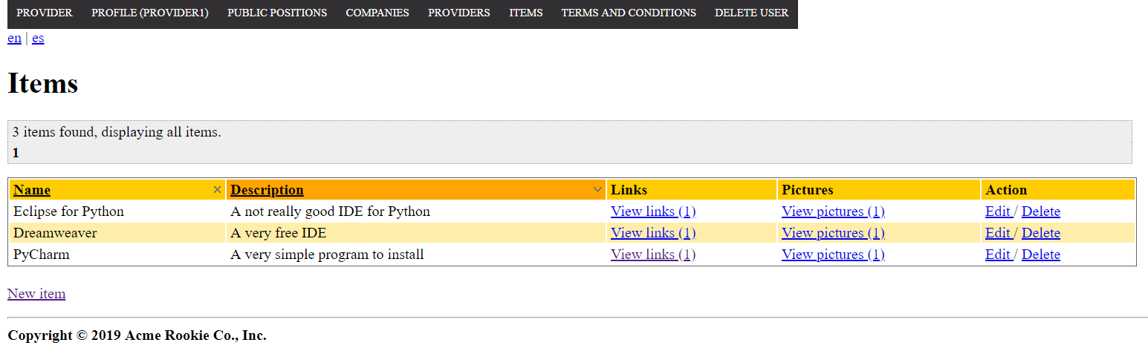

Tests

|  |  |
| --- | --- |
| Test 1 | |
| **Description** | *We must be able to delete an item using de link to delete in the “action” column.* |
| **Expected** | *If we click on delete in “PyCharm” item, the system must ask us for a confirmation to eliminate the item with a pop-up notification. When we confirm the deletion, the item must be deleted and the system will redirect us to the list of items directly. Now we will see two items instead of three.* |
| **Outcome** |  |
| **Notes** | *The expected results are based on the populate data.* |

|  |  |
| --- | --- |
| Test 2 | |
| **Description** | *We must not be able to delete an item that we have not published.* |
| **Expected** | *If we try to delete to delete an item with id (99999), using the url: /item/provider/delete.do?itemId=99999, the system will redirect us to the home page.* |
| **Outcome** |  |
| **Notes** | *The expected results are based on the populate data.* |

|  |  |
| --- | --- |
| Test 3 | |
| **Description** | *The system is available in two languages, so it must work correctly in both cases.* |
| **Expected** | *Changing the language, the expected results must be obtained in all the tests indicated above.* |
| **Outcome** |  |
| **Notes** | *The expected results are based on the populate data.* |

# Use case UC37: Logged as auditor, list and show his assignable positions to audit

Description

An user logged as an auditor must be able to list the assignable positions to audit. An auditor can only create an audit to positions that still don’t have an audit created by him.

Preconditions

*The shown views are based on the Populate Data.*

Access

*Homepage > Header Menu > Login*

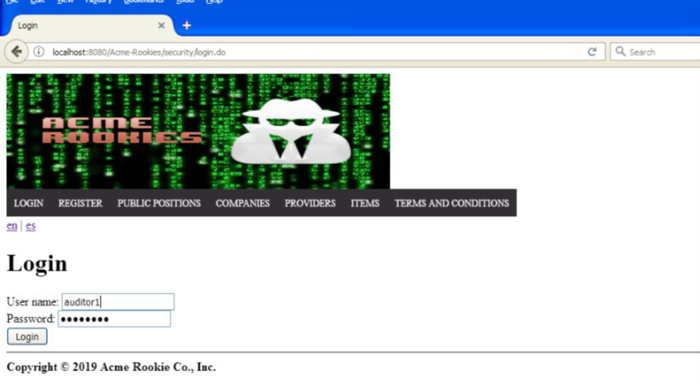

*Login as “auditor1/auditor1” > Header Menu > Display the "Auditor" options > Assing Position*

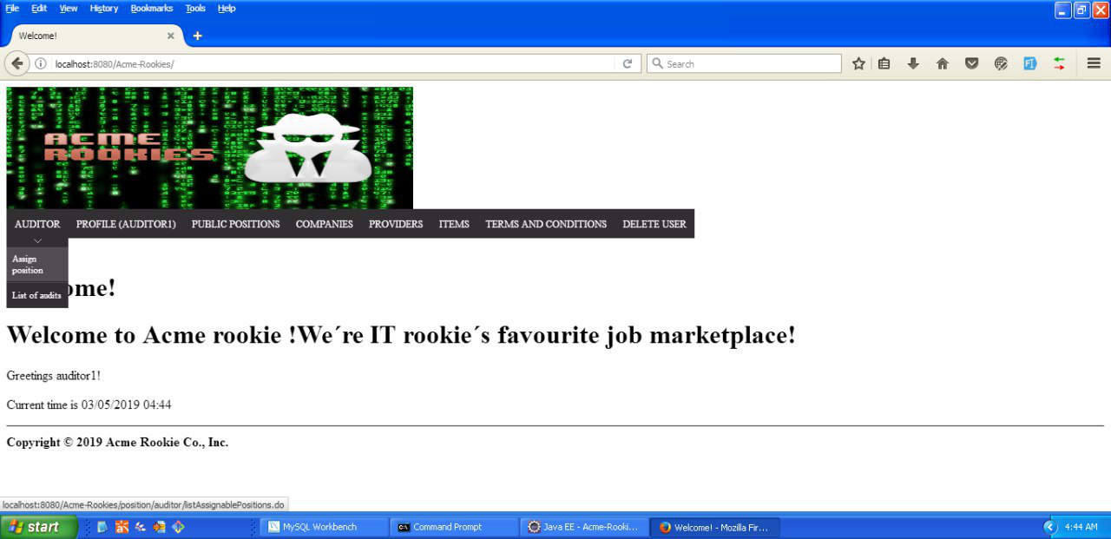

*The list of Assignable positions to audit will be displayed*

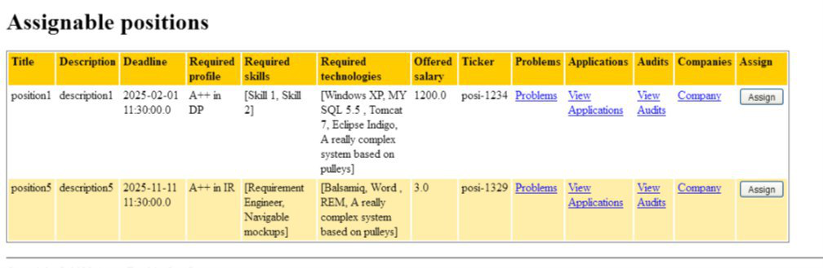

Tests

|  |  |
| --- | --- |
| Test 1 | |
| **Description** | *We must be able to see the list of audits that doesn’t have an audit created by the logged Auditor yet.* |
| **Expected** | *In the list table there should be the following columns: Title of the position, Description of the position, Deadline, Required Profile, Required Skills, Required Technologies, Offered Salary, ticker, a random sponsorship,links to the problems of the position, links to the applications of the position, links to the audits of the position and links to the profile of the Company that created the position.* |
| **Outcome** |  |
| **Notes** |  |

|  |  |
| --- | --- |
| Test 2 | |
| **Description** | *The positions displayed must be auditable.* |
| **Expected** | *The displayed positions must not be cancelled or in Draft Mode. Only the available positions to apply must be shown.* |
| **Outcome** |  |
| **Notes** |  |

|  |  |
| --- | --- |
| Test 3 | |
| **Description** | *Redirect links must work correctly* |
| **Expected** | *The links referring to the problems, applications, audits and company must redirect to the list of problems of the position, to the applications of the position, to the audits of the position and to the profile of the Company respectively. Example of these redirects for position1 logged as auditor1, the back link of each of these views must redirect to the list of assignable positions (/position/auditor/listAssignablePositions.do)* |
| **Outcome** |  |
| **Notes** |  |

|  |  |
| --- | --- |
| Test 4 | |
| **Description** | *We must be able to access to the creation form when the “assign” button is clicked.* |
| **Expected** | *The Assign button must be visible in the last column of the list. It must redirect to the audit creation (/audit/auditor/create.do?positionId=*) form correctly.* |
| **Outcome** |  |
| **Notes** |  |

|  |  |
| --- | --- |
| Test 5 | |
| **Description** | *Date format must be the correct one in english and spanish* |
| **Expected** | *When the list of positions to assign is displayed, the deadline column dates must follow the following format in english and spanish: yyyy-mm-dd hh:mm* |
| **Outcome** |  |
| **Notes** |  |

|  |  |
| --- | --- |
| Test 6 | |
| **Description** | *Pagination links must work correctly* |
| **Expected** | *When the list of positions to assign is displayed, the pagination links must allow the user to navigate to the next, previous, first and last page. The pagination will also allow the user to select a specific page by selecting the number of that page.* |
| **Outcome** |  |
| **Notes** |  |

|  |  |
| --- | --- |
| Test 7 | |
| **Description** | *The system is available in two languages, so it must work correctly in both cases.* |
| **Expected** | *Changing the language, the expected results must be obtained in all the tests indicated above.* |
| **Outcome** |  |
| **Notes** |  |

# Use case UC38: Logged as auditor, create an audit

Description

An user logged as an auditor can audit a position that doesn’t have an audit created by him.

Access

*First of all, the user must log as auditor in the login page. User: auditor1, Password: auditor1*

**

*Consequently, the user will display the list of assignable positions and click in the assign button of one of them.*

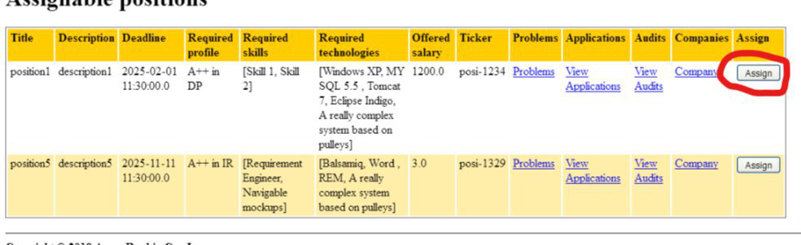

*The following form should be displayed:*

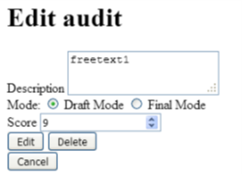

Tests

|  |  |
| --- | --- |
| Test 1 | |
| **Description** | Insert valid data in the form, the user must provide a description text (for example “description1”), select a mode (Final or Draft) and insert a score between 0 and 10. |
| **Expected** | The user will be redirected to the list of his audits (/position/auditor/listAssignablePositions.do). The new audit should be visible at the end of the list with the name of the position, the moment of creation, the description (in this case “description1”), the introduced score and the Status (mode) selected. If the Status selected was Draft, and Edit link should be shown in the last column. |
| **Outcome** |  |
| **Notes** |  |

|  |  |
| --- | --- |
| Test 2 | |
| **Description** | The user clicks in the “Cancel” Button. |
| **Expected** | When the user access to the Creation form, if he clicks in the “Cancel” button, he will be redirected to the list of Assignable positions (/position/auditor/listAssignablePositions.do) and the position that he tried to assign himself should be still available. |
| **Outcome** |  |
| **Notes** |  |

|  |  |
| --- | --- |
| Test 3 | |
| **Description** | The Auditor tries to edit an Audit that has been saved in Final Mode. |
| **Expected** | The saved audit cannot be edited, the edit button in the last column of the list of audits won’t be shown, and the edition view will not be accessible by URL (It would be considered GET Hacking). If this happen the user will be redirected to the list of audits (/position/auditor/listAssignablePositions.do). |
| **Outcome** |  |
| **Notes** |  |

|  |  |
| --- | --- |
| Test 4 | |
| **Description** | The user provides a blank description. |
| **Expected** | The audit won’t be saved in the system and a message indicating that the description cannot be blank will be shown. |
| **Outcome** |  |
| **Notes** |  |

|  |  |
| --- | --- |
| Test 5 | |
| **Description** | The user provides a null score. |
| **Expected** | The audit won’t be saved in the system and a message indicating that the score cannot be null will be shown. |
| **Outcome** |  |
| **Notes** |  |

|  |  |
| --- | --- |
| Test 6 | |
| **Description** | The user provides a score that is out of range (bigger than 10 or smaller than 0). |
| **Expected** | The audit won’t be saved in the system and a message indicating that the score must be in the range between 0 and 10 will be shown. |
| **Outcome** |  |
| **Notes** |  |

|  |  |
| --- | --- |
| Test 7 | |
| **Description** | The user provides a score that is not an Integer value (String, double…) |
| **Expected** | The audit won’t be saved in the system and a message indicating that an Invalid value has been introduced in the Score field. |
| **Outcome** |  |
| **Notes** |  |

|  |  |
| --- | --- |
| Test 8 | |
| **Description** | An XSS or SQL Sentence is inserted in the Description field. |
| **Expected** | The Sentence will be saved as the description of the audit. The content of the sentence won’t affect the database because SQL Injections have been prevented. |
| **Outcome** |  |
| **Notes** |  |

|  |  |
| --- | --- |
| Test 9 | |
| **Description** | The user tries to change the position assigned or the Auditor that Created the Audit. |
| **Expected** | These fields won’t be affected because the form has been correctly pruned. |
| **Outcome** |  |
| **Notes** |  |

|  |  |
| --- | --- |
| Test 10 | |
| **Description** | *The system is available in two languages, so it must work correctly in both cases.* |
| **Expected** | *Changing the language, the expected results must be obtained in all the tests indicated above.* |
| **Outcome** |  |
| **Notes** |  |

# Use case UC39: Logged as Auditor, list his audits.

Description

An user logged as Auditor must be able to edit his audits, which includes creating, editing and deleting them. An audit can be updated or deleted as long as it’s saved in Draft Mode.

Access

*First of all, the user must log as auditor in the login page. User: auditor1, Password: auditor1*

**

Consequently, the user will display his list of audits by clicking “List of audits” in the home bar.

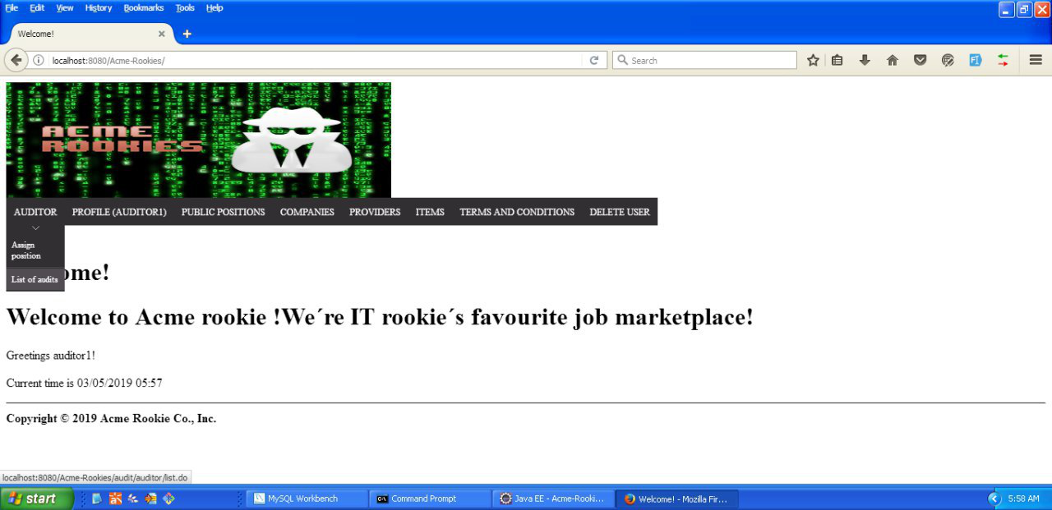

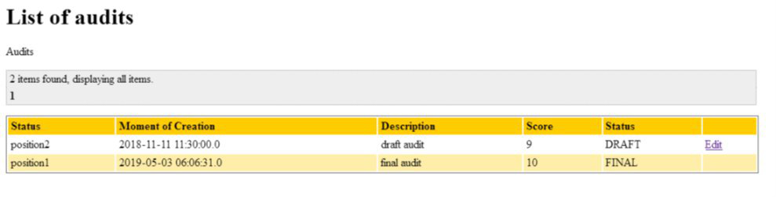

Tests

|  |  |
| --- | --- |
| Test 1 | |
| **Description** | *The list of audits is displayed after following the previous steps.* |
| **Expected** | *All the audits displayed in this view must belong to the logged auditor. The editing link must be shown only in the audits that are in Draft Mode. There will be no draft audits referring to a cancelled positions (draft audits are deleted whenever its position is cancelled). There won’t be audits referring to positions that are in Draft Mode.* |
| **Outcome** |  |
| **Notes** |  |

|  |  |
| --- | --- |
| Test 2 | |
| **Description** | *Pagination links must work correctly* |
| **Expected** | *When the list of audits that belongs to the logged auditor is displayed, the pagination links must allow the user to navigate to the next, previous, first and last page. The pagination will also allow the user to select a specific page by selecting the number of that page.* |
| **Outcome** |  |
| **Notes** |  |

|  |  |
| --- | --- |
| Test 3 | |
| **Description** | *The status of an audit must be comprehensible by the user.* |
| **Expected** | *The status of an audit(draft or final) is stored in the system as a boolean. When the user displays a list of audits the system must show DRAFT and FINAL instead or TRUE and FALSE.* |
| **Outcome** |  |
| **Notes** |  |

|  |  |
| --- | --- |
| Test 4 | |
| **Description** | *Date format must be the correct one in english and spanish* |
| **Expected** | *When the list of audits that belongs to the logged auditor, the creation date column dates must follow the following format in english and spanish: yyyy-mm-dd hh:mm* |
| **Outcome** |  |
| **Notes** |  |

|  |  |
| --- | --- |
| Test 5 | |
| **Description** | *The user clicks on the edit link* |
| **Expected** | *The user will be redirected to the edition form (only if the audit is in Draft Mode).* |
| **Outcome** |  |
| **Notes** |  |

|  |  |
| --- | --- |
| Test 6 | |
| **Description** | *The system is available in two languages, so it must work correctly in both cases.* |
| **Expected** | *Changing the language, the expected results must be obtained in all the tests indicated above.* |
| **Outcome** |  |
| **Notes** |  |

# Use case UC40: Logged as auditor, edit or delete an Audit

Description

An user logged as Auditor must be able to edit his audits, which includes creating, editing and deleting them. An audit can be updated or deleted as long as it’s saved in Draft Mode.

Access

*Homepage > Header Menu > Login*

**

*Consequently, the user will display his list of audits by clicking “List of audits” in the home bar.*





*After clicking on the “edit” link in the last column, the user will access to the edition form (Note that this link should only appear if the Audit is in Draft Mode).*

Tests

|  |  |
| --- | --- |
| Test 1 | |
| **Description** | Insert valid data in the form, the user must provide a description text (for example “newDescription1”), select a mode (Final or Draft) and insert a score between 0 and 10. |
| **Expected** | The user will be redirected to the list of his audits (/position/auditor/listAssignablePositions.do). The edited audit should be visible in the list with the name of the position, the moment of creation, the description (in this case “newDescription1”), the new score and the Status (mode) selected. If the Status selected was Draft, and Edit link should be shown in the last column. If the status selected was final, the audit won’t be no longer editable. |
| **Outcome** |  |
| **Notes** |  |

|  |  |
| --- | --- |
| Test 2 | |
| **Description** | The user edits one of this draft audits and clicks in the delete button. |
| **Expected** | The audit will be deleted from the system and the assigned position will be assignable by the auditor again. |
| **Outcome** |  |
| **Notes** |  |

|  |  |
| --- | --- |
| Test 3 | |
| **Description** | The user tries to edit one of his audits in Final Mode by inserting it id in the URL (GET hacking) |
| **Expected** | The user will be redirected to the list view (/position/auditor/listAssignablePositions.do). |
| **Outcome** |  |
| **Notes** |  |

|  |  |
| --- | --- |
| Test 4 | |
| **Description** | The user clicks in the “Cancel” Button. |
| **Expected** | When the user access to the Edition form, if he clicks in the “Cancel” button, he will be redirected to the list of Assignable positions (/position/auditor/listAssignablePositions.do). |
| **Outcome** |  |
| **Notes** |  |

|  |  |
| --- | --- |
| Test 5 | |
| **Description** | The user provides a blank description. |
| **Expected** | The audit won’t be updated and a message indicating that the description cannot be blank will be shown. |
| **Outcome** |  |
| **Notes** |  |

|  |  |
| --- | --- |
| Test 6 | |
| **Description** | The user provides a null score. |
| **Expected** | The audit won’t be updated and a message indicating that the score cannot be null will be shown. |
| **Outcome** |  |
| **Notes** |  |

|  |  |
| --- | --- |
| Test 7 | |
| **Description** | The user provides a score that is out of range (bigger than 10 or smaller than 0). |
| **Expected** | The audit won’t be updated and a message indicating that the score must be in the range between 0 and 10 will be shown. |
| **Outcome** |  |
| **Notes** |  |

|  |  |
| --- | --- |
| Test 8 | |
| **Description** | The user provides a score that is not an Integer value (String, double…) |
| **Expected** | The audit won’t be updated and a message indicating that an Invalid value has been introduced in the Score field. |
| **Outcome** |  |
| **Notes** |  |

|  |  |
| --- | --- |
| Test 9 | |
| **Description** | An XSS or SQL Sentence is inserted in the Description field. |
| **Expected** | The Sentence will be saved as the description of the audit. The content of the sentence won’t affect the database because SQL Injections have been prevented. |
| **Outcome** |  |
| **Notes** |  |

|  |  |
| --- | --- |
| Test 10 | |
| **Description** | The user tries to change the position assigned or the Auditor that Created the Audit. |
| **Expected** | These fields won’t be affected because the form has been correctly pruned. |
| **Outcome** |  |
| **Notes** |  |

|  |  |
| --- | --- |
| Test 11 | |
| **Description** | *The system is available in two languages, so it must work correctly in both cases.* |
| **Expected** | *Changing the language, the expected results must be obtained in all the tests indicated above.* |
| **Outcome** |  |
| **Notes** |  |

# 

# Use case UC41: Logged as Admin, update the score of the Companies of the system

Description

An actor who is authenticated as an administrator must be able to launch a process to compute an audit score for every company. The audit score is computed as the average of the audit scores that the positions offered by a company has got, but normalised to range 0.00 up to +1.00 using a linear homothetic transformation. Note that the audit score of a company that hasn’t got any audits is not 0.00, but nil.

Preconditions

*The shown views are based on the Populate Data.*

Access

*Homepage > Header Menu > Login*

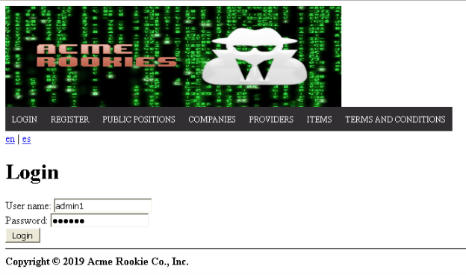

*Login as “admin1/admin1” > Header Menu > Administrator > Compute scores*

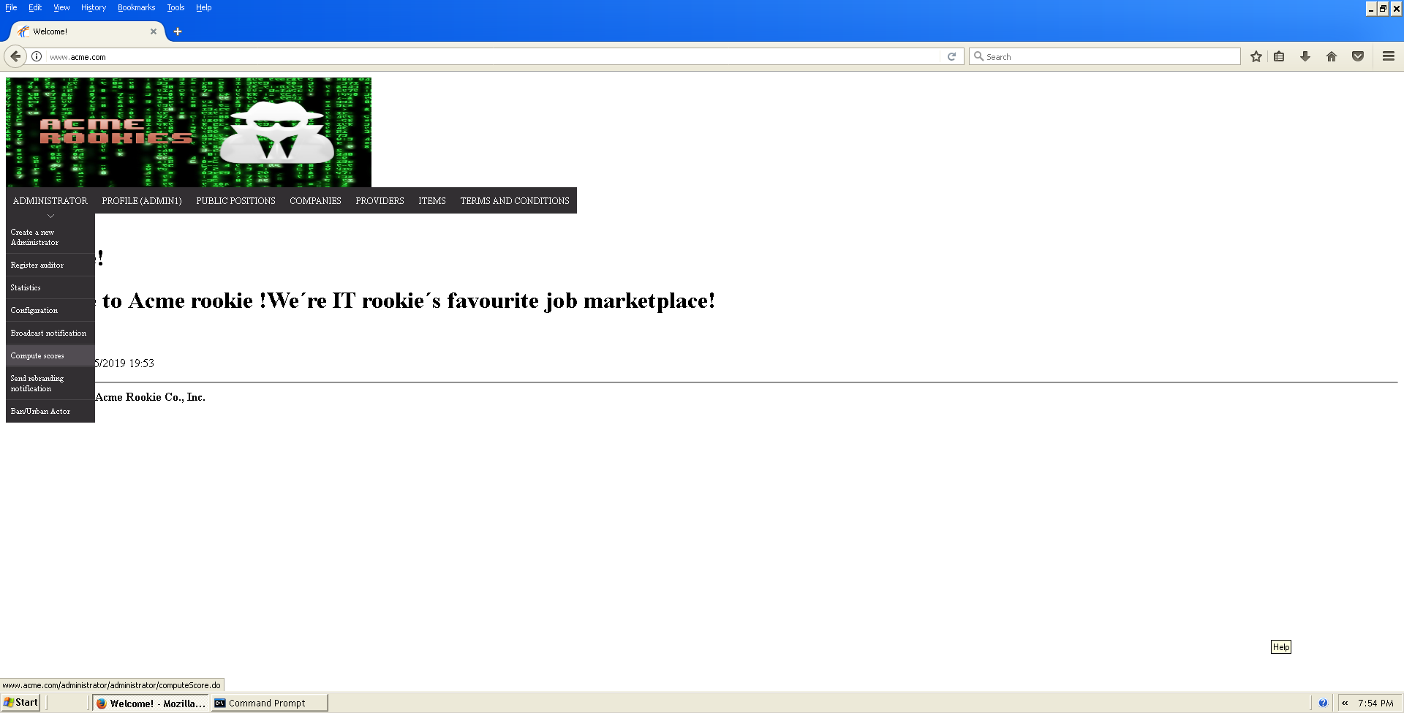

*The scores of the companies of the system will be recalculated and displayable in the public data available for every user (/anonymous/company/list.do).*

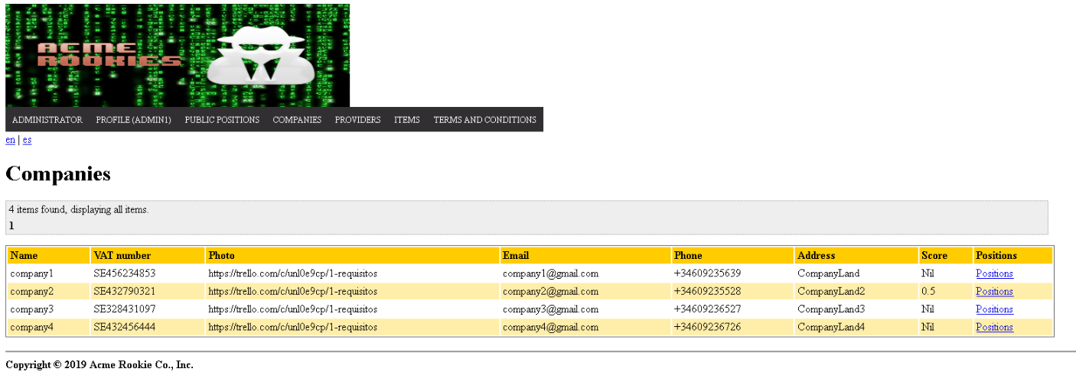

Tests

|  |  |
| --- | --- |
| Test 1 | |
| **Description** | *The score of every Company must be in the range between 0.00 and 1.00, if a Company has no Audits, his score will be Nil instead of 0.00* |
| **Expected** |  |
| **Outcome** |  |
| **Notes** |  |

|  |  |
| --- | --- |
| Test 2 | |
| **Description** | *The system is available in two languages, so it must work correctly in both cases.* |
| **Expected** | *Changing the language, the expected results must be obtained in all the tests indicated above.* |
| **Outcome** |  |
| **Notes** |  |

# Use case UC42: Logged as admin, display a Dashboard with the following information

Description

An actor who is authenticated as an administrator must be able to display a dashboard with the following information:

* The average, the minimum, the maximum, and the standard deviation of the number of positions per company.
* The average, the minimum, the maximum, and the standard deviation of the number of applications per hacker.
* The companies that have offered more positions.
* The hackers who have made more applications.
* The average, the minimum, the maximum, and the standard deviation of the salaries offered.
* The best and the worst position in terms of salary.

Preconditions

*The shown views are based on the Populate Data.*

Access

*Homepage > Header Menu > Login*

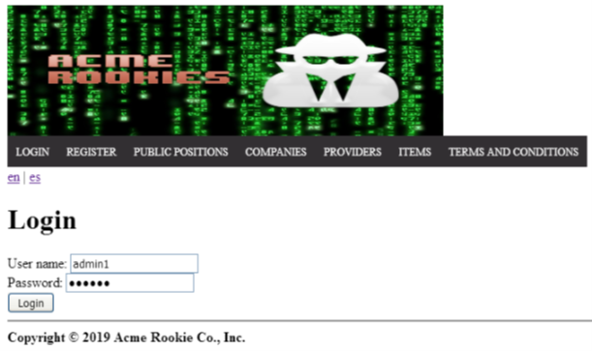

*Login as “admin1/admin1” (for example, but all the admins of the system should be able to display the statistics dashboard) > Administrator > Statistics*

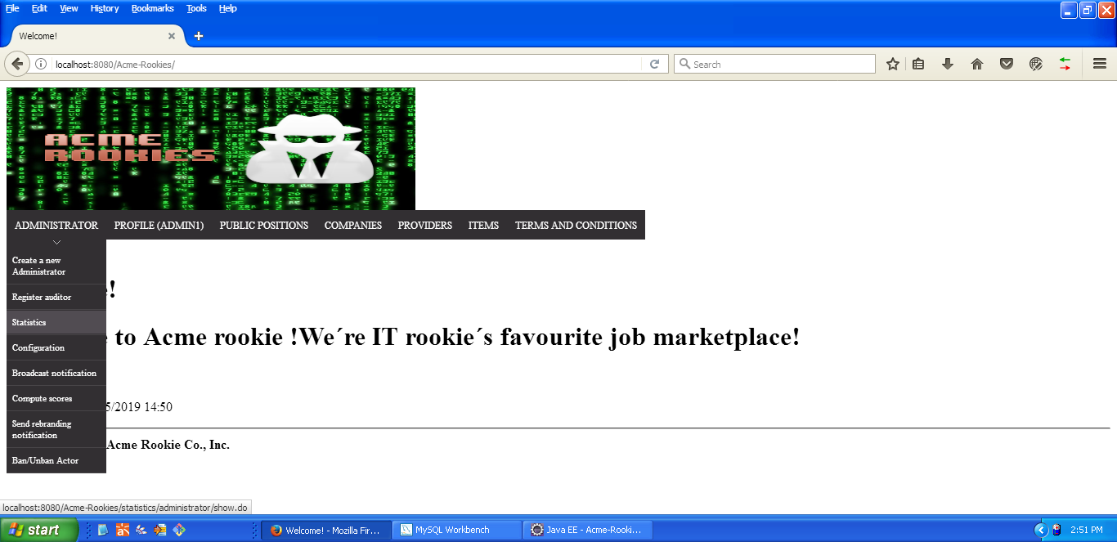

*The statistics dashboard should be displayed*

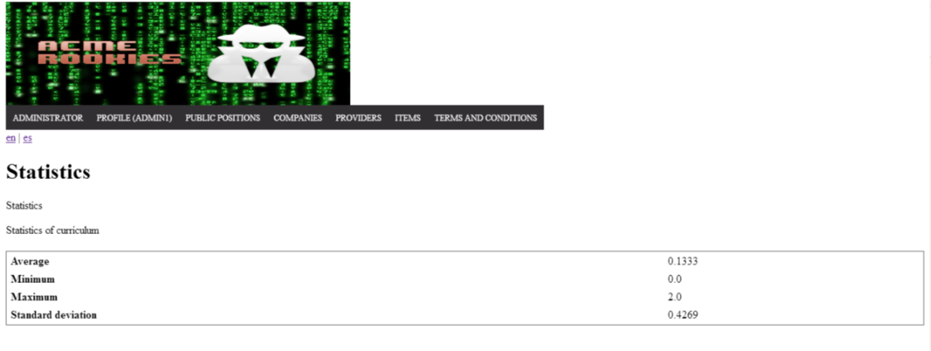

Tests

|  |  |
| --- | --- |
| Test 1 | |
| **Description** | *We must be able to see the dashboard of statistics of the system* |
| **Expected** | *In the list table there should be the following information:*   * The average, the minimum, the maximum, and the standard deviation of the number of positions per company. * The average, the minimum, the maximum, and the standard deviation of the number of applications per hacker. * The companies that have offered more positions. * The hackers who have made more applications. * The average, the minimum, the maximum, and the standard deviation of the salaries offered. * The best and the worst position in terms of salary. |
| **Outcome** |  |
| **Notes** |  |

|  |  |
| --- | --- |
| Test 2 | |
| **Description** | *The system is available in two languages, so it must work correctly in both cases.* |
| **Expected** | *Changing the language, the expected results must be obtained in all the tests indicated above.* |
| **Outcome** |  |
| **Notes** |  |

# Use case UC43: Logged as admin, display a Dashboard with the following information

Description

An actor who is authenticated as an administrator must be able to display a dashboard with the following information:

* The minimum, the maximum, the average, and the standard deviation of the number of curricula per hacker.
* The minimum, the maximum, the average, and the standard deviation of the number of results in the finders.
* The ratio of empty versus non-empty finders.

Preconditions

*The shown views are based on the Populate Data.*

Preconditions

*The shown views are based on the Populate Data.*

Access

*Homepage > Header Menu > Login*

**

*Login as “admin1/admin1” (for example, but all the admins of the system should be able to display the statistics dashboard) > Administrator > Statistics*

**

*The statistics dashboard should be displayed*

**

Tests

|  |  |
| --- | --- |
| Test 1 | |
| **Description** | *We must be able to see the dashboard of statistics of the system* |
| **Expected** | *In the list table there should be the following information:*   * The minimum, the maximum, the average, and the standard deviation of the number of curricula per hacker. * The minimum, the maximum, the average, and the standard deviation of the number of results in the finders. * The ratio of empty versus non-empty finders. |
| **Outcome** |  |
| **Notes** |  |

|  |  |
| --- | --- |
| Test 2 | |
| **Description** | *The system is available in two languages, so it must work correctly in both cases.* |
| **Expected** | *Changing the language, the expected results must be obtained in all the tests indicated above.* |
| **Outcome** |  |
| **Notes** |  |

# Use case UC44: Logged as admin, display a Dashboard with the following information

Description

An actor who is authenticated as an administrator must be able to display a dashboard with the following information:

* The average, the minimum, the maximum, and the standard deviation of the audit score of the positions stored in the system.
* The average, the minimum, the maximum, and the standard deviation of the audit score of the companies that are registered in the system.
* The companies with the highest audit score.
* The average salary offered by the positions that have the highest average audit score.

Preconditions

*The shown views are based on the Populate Data.*

Preconditions

*The shown views are based on the Populate Data.*

Access

*Homepage > Header Menu > Login*

**

*Login as “admin1/admin1” (for example, but all the admins of the system should be able to display the statistics dashboard) > Administrator > Statistics*

**

*The statistics dashboard should be displayed*

**

Tests

|  |  |
| --- | --- |
| Test 1 | |
| **Description** | *We must be able to see the dashboard of statistics of the system* |
| **Expected** | *In the list table there should be the following information:*   * The average, the minimum, the maximum, and the standard deviation of the audit score of the positions stored in the system. * The average, the minimum, the maximum, and the standard deviation of the audit score of the companies that are registered in the system. * The companies with the highest audit score. * The average salary offered by the positions that have the highest average audit score. |
| **Outcome** |  |
| **Notes** |  |

|  |  |
| --- | --- |
| Test 2 | |
| **Description** | *The system is available in two languages, so it must work correctly in both cases.* |
| **Expected** | *Changing the language, the expected results must be obtained in all the tests indicated above.* |
| **Outcome** |  |
| **Notes** |  |

# Use case UC45: Logged as admin, display a Dashboard with the following information

Description

An actor who is authenticated as an administrator must be able to display a dashboard with the following information:

* The minimum, the maximum, the average, and the standard deviation of the number of items per provider.
* The top-5 providers in terms of total number of items provided

Preconditions

*The shown views are based on the Populate Data.*

Access

*Homepage > Header Menu > Login*

**

*Login as “admin1/admin1” (for example, but all the admins of the system should be able to display the statistics dashboard) > Administrator > Statistics*

**

*The statistics dashboard should be displayed*

**

Tests

|  |  |
| --- | --- |
| Test 1 | |
| **Description** | *We must be able to see the dashboard of statistics of the system* |
| **Expected** | *In the list table there should be the following information:*   * The minimum, the maximum, the average, and the standard deviation of the number of items per provider. * The top-5 providers in terms of total number of items provided |
| **Outcome** |  |
| **Notes** |  |

|  |  |
| --- | --- |
| Test 2 | |
| **Description** | *The system is available in two languages, so it must work correctly in both cases.* |
| **Expected** | *Changing the language, the expected results must be obtained in all the tests indicated above.* |
| **Outcome** |  |
| **Notes** |  |

# Use case UC46: Logged as admin, display a Dashboard with the following information

Description

An actor who is authenticated as an administrator must be able to display a dashboard with the following information:

* The average, the minimum, the maximum, and the standard deviation of the number of sponsorships per provider.
* The average, the minimum, the maximum, and the standard deviation of the number of sponsorships per position.
* The providers who have a number of sponsorships that is at least 10% above the average number of sponsorships per provider.

Preconditions

*The shown views are based on the Populate Data.*

Access

*Homepage > Header Menu > Login*

**

*Login as “admin1/admin1” (for example, but all the admins of the system should be able to display the statistics dashboard) > Administrator > Statistics*

**

*The statistics dashboard should be displayed*

**

Tests

|  |  |
| --- | --- |
| Test 1 | |
| **Description** | *We must be able to see the dashboard of statistics of the system* |
| **Expected** | *In the list table there should be the following information:*   * The average, the minimum, the maximum, and the standard deviation of the number of sponsorships per provider. * The average, the minimum, the maximum, and the standard deviation of the number of sponsorships per position. * The providers who have a number of sponsorships that is at least 10% above the average number of sponsorships per provider. |
| **Outcome** |  |
| **Notes** |  |

|  |  |
| --- | --- |
| Test 2 | |
| **Description** | *The system is available in two languages, so it must work correctly in both cases.* |
| **Expected** | *Changing the language, the expected results must be obtained in all the tests indicated above.* |
| **Outcome** |  |
| **Notes** |  |

# Use case UC47: Logged as rookie, list curriculums

Description

An user logged as an rookie must be able to list his curriculums.

Preconditions

*The shown views are based on the Populate Data.*

Access

*Homepage > Header Menu > Login*

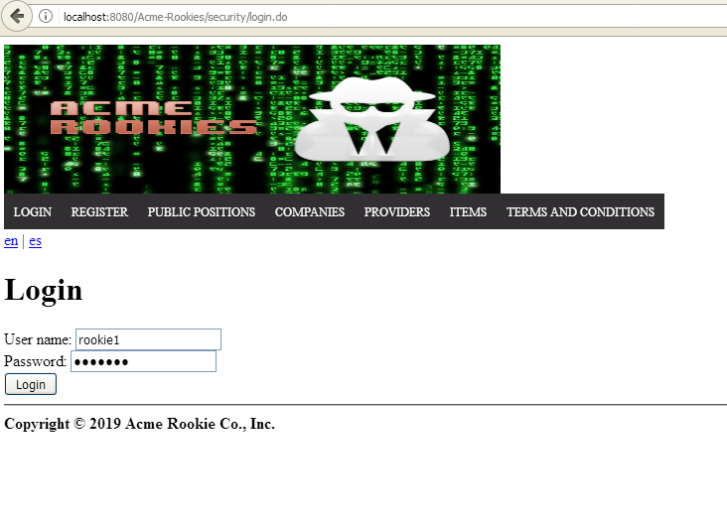

*Login as “rookie1/rookie1” > Header Menu > Display the "Rookie" options > Curriculums*

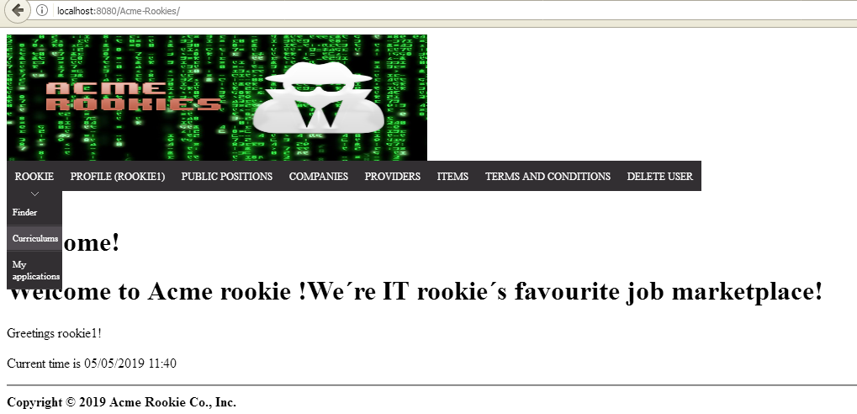*The list of curriculums will be displayed*

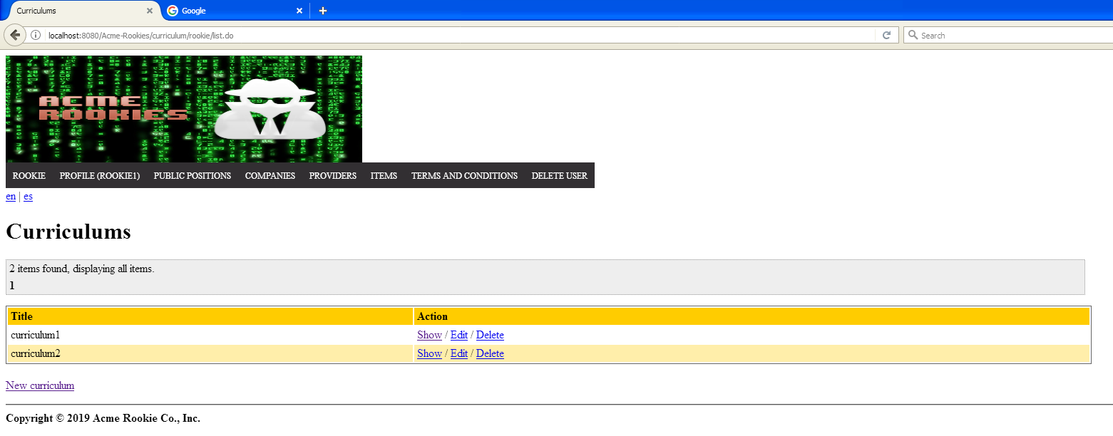

Tests

|  |  |
| --- | --- |
| Test 1 | |
| **Description** | *List of current logged rookie.* |
| **Expected** |  |
| **Outcome** |  |
| **Notes** |  |

|  |  |
| --- | --- |
| Test 2 | |
| **Description** | *Show a curriculum. Click on “Show” from “curriculum2”* |
| **Expected** | *A new view with all data from “curriculum2”.* |
| **Outcome** |  |
| **Notes** |  |

# Use case UC48: Logged as rookie, edit curriculums

Description

*An actor who is authenticated as a rookie must be able to edit their curricula.*

Preconditions

*The shown views are based on the Populate Data.*

Access

*From the list curriculum of the previously test, click on “edit”.*

Tests

|  |  |
| --- | --- |
| Test 1 | |
| **Description** | *Update personal data of a curriculum. “curriculum2” will be edited. First of all we will try to break some constraints about the attributes of personal data, test in order:*  *-All fields Blank.*  *-Invalid URLs in profile fields.* |
| **Expected** | *Expected results in order:* |
| **Outcome** |  |
| **Notes** |  |

|  |  |
| --- | --- |
| Test 2 | |
| **Description** | *Update personal data of a curriculum. “curriculum2” will be edited.* |
| **Expected** |  |
| **Outcome** |  |
| **Notes** |  |

# Use case UC49: Logged as rookie, edit Position Data

Description

*An actor who is authenticated as a rookie must be able to list, create and edit their position Data.*

Preconditions

*The shown views are based on the Populate Data.*

Access

*From the view of the previously test, click on “New Position Data”*

Tests

|  |  |
| --- | --- |
| Test 1 | |
| **Description** | *Create position data. We will try to break some constraints about the attributes of position data, test in order:*  *-All fields blank.*  *-Invalid moments in start and end date.*  *-Future moments for start and end date.*  *-Start date after end date.* |
| **Expected** |  |
| **Outcome** |  |
| **Notes** |  |

|  |  |
| --- | --- |
| Test 2 | |
| **Description** | *Create position data. The following values can be used:* |
| **Expected** |  |
| **Outcome** |  |
| **Notes** |  |

|  |  |
| --- | --- |
| Test 3 | |
| **Description** | *Edit position data wrong. We will try to break some constraints about the attributes of position data, test in order:*  *-All fields blank.*  *-Invalid moments in start and end date.*  *-Future moments for start and end date.*  *-Start date after end date.* |
| **Expected** |  |
| **Outcome** |  |
| **Notes** |  |

|  |  |
| --- | --- |
| Test 4 | |
| **Description** | *Edit position data. We will edit the position data created previously with the following values:* |
| **Expected** |  |
| **Outcome** |  |
| **Notes** |  |

# Use case UC50: Logged as rookie, edit Education Data

Description

*An actor who is authenticated as a rookie must be able to list, create and edit their education Data.*

Preconditions

*The shown views are based on the Populate Data.*

Access

*From the view of the previously test, click on “New Education Data”*

Tests

|  |  |
| --- | --- |
| Test 1 | |
| **Description** | *Create education data. We will try to break some constraints about the attributes of education data, test in order:*  *-All fields blank.*  *-Invalid moments in start and end date.*  *-Future moments for start and end date.*  *-Start date after end date.* |
| **Expected** |  |
| **Outcome** |  |
| **Notes** |  |

|  |  |
| --- | --- |
| Test 2 | |
| **Description** | *Create education data. The following values can be used:* |
| **Expected** |  |
| **Outcome** |  |
| **Notes** |  |

|  |  |
| --- | --- |
| Test 3 | |
| **Description** | *Edit education data. We will try to break some constraints about the attributes of education data, test in order:*  *-All fields blank.*  *-Invalid moments in start and end date.*  *-Future moments for start and end date.*  *-Start date after end date.* |
| **Expected** |  |
| **Outcome** |  |
| **Notes** |  |

|  |  |
| --- | --- |
| Test 4 | |
| **Description** | *Edit education data, we will edit the education data created previously with the following values:* |
| **Expected** |  |
| **Outcome** |  |
| **Notes** |  |

# Use case UC51: Logged as rookie, edit Miscellaneous Data

Description

*An actor who is authenticated as a rookie must be able to list, create and edit their miscellaneous Data and their attachments.*

Preconditions

*The shown views are based on the Populate Data.*

Access

*From the view of the previously test, click on “New Miscellaneous Data”*

Tests

|  |  |
| --- | --- |
| Test 1 | |
| **Description** | *Create miscellaneous data, we will try to break some constraints about the attributes of miscellaneous data, test in order:*  *-Free text blank.* |
| **Expected** |  |
| **Outcome** |  |
| **Notes** |  |

|  |  |
| --- | --- |
| Test 2 | |
| **Description** | *Create miscellaneous data, the following values can be used:* |
| **Expected** |  |
| **Outcome** |  |
| **Notes** |  |

|  |  |
| --- | --- |
| Test 3 | |
| **Description** | *List attachments. Test the view of list attachments by clicking on “View attachments” of the miscellaneous data previously created.* |
| **Expected** |  |
| **Outcome** |  |
| **Notes** |  |

|  |  |
| --- | --- |
| Test 4 | |
| **Description** | *Create attachment, we will try to break some constraints about attachments. Try to create an attachment whose value is blank and then not a valid URL.* |
| **Expected** |  |
| **Outcome** |  |
| **Notes** |  |

|  |  |
| --- | --- |
| Test 5 | |
| **Description** | *Create attachment, the following value can be used:* |
| **Expected** |  |
| **Outcome** |  |
| **Notes** |  |

|  |  |
| --- | --- |
| Test 6 | |
| **Description** | *Edit miscellaneous data, we will try to break some constraints about the attributes of miscellaneous data, test in order:*  *-Free text blank.* |
| **Expected** |  |
| **Outcome** |  |
| **Notes** |  |

|  |  |
| --- | --- |
| Test 7 | |
| **Description** | *Edit miscellaneous data, the following values can be used:* |
| **Expected** |  |
| **Outcome** |  |
| **Notes** |  |

# Use case UC52: Logged as rookie, delete Data and Curriculum

Description

*An actor who is authenticated as a rookie must be able to delete any of their Data and any of their curriculums.*

Preconditions

*The shown views are based on the Populate Data.*

Access

*From the view of the previously test, click on “View Attachments” from the newest Miscellaneous Record and click “delete” in the only attachment of the view.*

Tests

|  |  |
| --- | --- |
| Test 1 | |
| **Description** | *Delete attachment, we will test by deleting the attachment previously created.* |
| **Expected** |  |
| **Outcome** |  |
| **Notes** |  |

|  |  |
| --- | --- |
| Test 2 | |
| **Description** | *Delete miscellaneous data, we will test by deleting the miscellaneous data previously created.* |
| **Expected** |  |
| **Outcome** |  |
| **Notes** |  |

|  |  |
| --- | --- |
| Test 3 | |
| **Description** | *Delete education data, we will test by deleting the education data previously created.* |
| **Expected** |  |
| **Outcome** |  |
| **Notes** |  |

|  |  |
| --- | --- |
| Test 4 | |
| **Description** | *Delete position data, we will test by deleting the position data previously created.* |
| **Expected** |  |
| **Outcome** |  |
| **Notes** |  |

|  |  |
| --- | --- |
| Test 5 | |
| **Description** | *Delete curriculum, we will test by deleting the curriculum that has been tested until now.* |
| **Expected** |  |
| **Outcome** |  |
| **Notes** |  |

# Use case UC53: Logged as rookie, create Curriculum

Description

*An actor who is authenticated as a rookie must be able to create a curriculum.*

Preconditions

*The shown views are based on the Populate Data.*

Access

*From the view of the previously test, click on “New Curriculum”*

Tests

|  |  |
| --- | --- |
| Test 1 | |
| **Description** | *Create curriculum, we will test the constraints over the attributes of curriculum and the different alerts about the telephone. Test in order:*  *-All fields blank, an alert about the telephone being blank is expected.*  *-Profile fields with an invalid url and telephone field with a value not matching +34xxxxxxxxx, an alert about the format being incorrect is expected.* |
| **Expected** |  |
| **Outcome** |  |
| **Notes** |  |

|  |  |
| --- | --- |
| Test 2 | |
| **Description** | *Create curriculum, the following values can be used:* |
| **Expected** |  |
| **Outcome** |  |
| **Notes** |  |

# Use case UC54: Logged as rookie, Data protection

Description

*An actor who is authenticated as a rookie shouldn’t be able to see or edit any data from other rookie’s curriculums.*

Preconditions

*The shown views are based on the Populate Data.*

Access

*Doesn’t need any more than be logged as a rookie.*

Tests

|  |  |
| --- | --- |
| Test 1 | |
| **Description** | *Forced URLs 1: try the next URLs models to force a prohibited action (Note that the ids could not match the ones on your database, please correct them if you deemed it necessary):* |
| **Expected** | *In all cases it will redirect to list curriculums.* |
| **Outcome** |  |
| **Notes** |  |

|  |  |
| --- | --- |
| Test 2 | |
| **Description** | *Forced URLs 2: try the next URLs models to force a prohibited action (Note that the ids could not match the ones on your database, please correct them if you deemed it necessary), once in the views try to perform the correspondent action:* |
| **Expected** | *In all cases a commit error is expected.* |
| **Outcome** |  |
| **Notes** |  |

# Use case UC55: Logged as any actor, list your social profiles

Description

The actors of the system can register their social profiles. The system must store the following data regarding them: a nick, the name of the social network, a link to a profile in that social network.

Preconditions

*The shown views are based on the Populate Data.*

Access

*Homepage > Header Menu > Login*

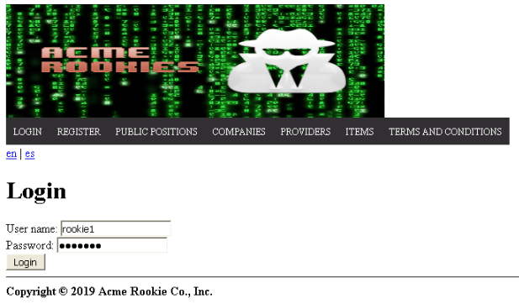

*Login as “rookie1/rookie1” (for example, but all the accounts of the system should be able to list his Social Profiles) > Header Menu > Profile(Username) > My Profile*

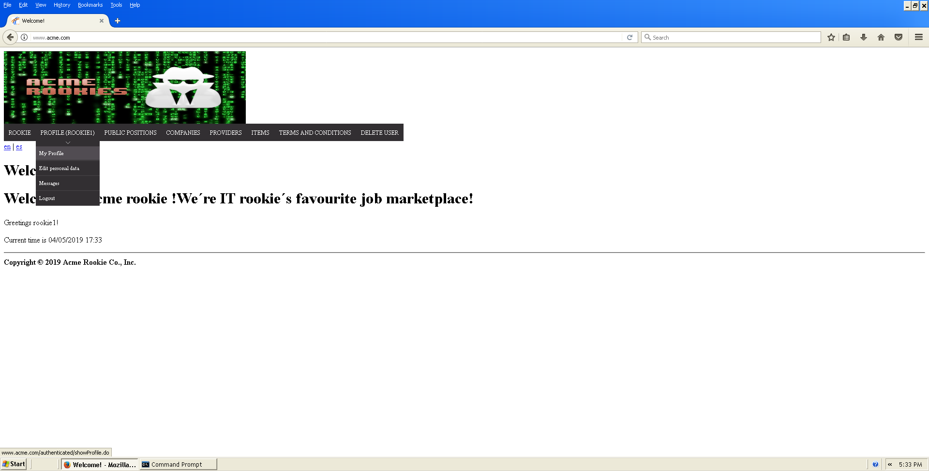

*The list of Social Profiles that belongs to the logged actor will be displayed*

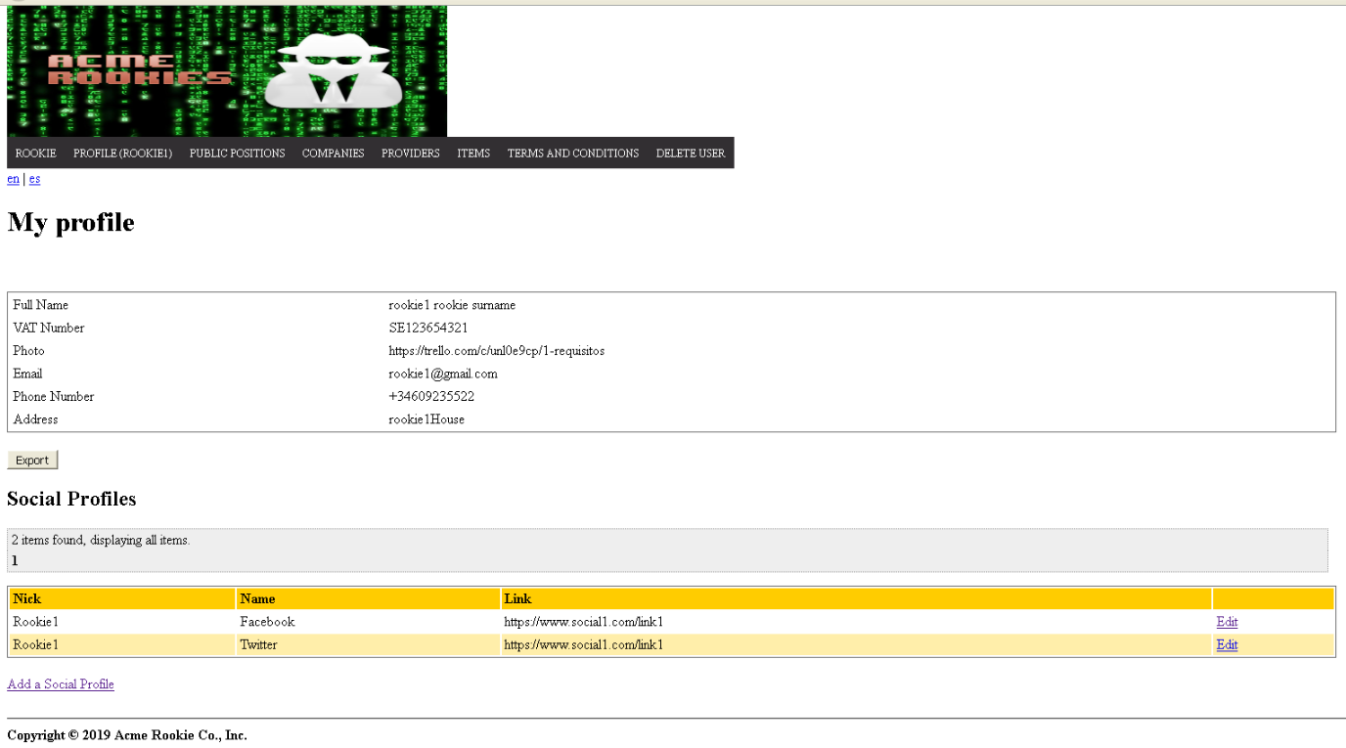

Tests

|  |  |
| --- | --- |
| Test 1 | |
| **Description** | *We must be able to see the list of Social Profiles of the logged Actor* |
| **Expected** | *In the list table there should be the following columns: A Nick, The Name of the Social Network and A link to a profile in that Social Network. There is no possibility of GET hacking because there are no ids in the URL.* |
| **Outcome** |  |
| **Notes** |  |

|  |  |
| --- | --- |
| Test 2 | |
| **Description** | *The Social Profiles shown must be editable and users should be able to create new Social Profiles.* |
| **Expected** | *There should be one edit link for each Social Profiles that redirects to a Edit form with the data of the corresponding Social Profile and a Create Button that redirects to an Empty Creation form.*    Creation form:    Edition form: |
| **Outcome** |  |
| **Notes** |  |

|  |  |
| --- | --- |
| Test 3 | |
| **Description** | *The links of all the companies of the system can be displayed in the public data. Header Menu > Public Positions > Click the “Company” link* |
| **Expected** | *The columns should be the same than in Test 1, excepting the “Edit” and “Add Social Profile links.* |
| **Outcome** |  |
| **Notes** |  |

|  |  |
| --- | --- |
| Test 4 | |
| **Description** | *Pagination links must work correctly* |
| **Expected** | *When the list of Social Profiles is displayed, the pagination links must allow the user to navigate to the next, previous, first and last page. The pagination will also allow the user to select a specific page by selecting the number of that page.* |
| **Outcome** |  |
| **Notes** |  |

|  |  |
| --- | --- |
| Test 7 | |
| **Description** | *The system is available in two languages, so it must work correctly in both cases.* |
| **Expected** | *Changing the language, the expected results must be obtained in all the tests indicated above.* |
| **Outcome** |  |
| **Notes** |  |

# Use case UC56: Logged as actor, create a Social Profile and edit one of your Social Profiles

Description

An actor who is authenticated must be able to: Manage his or her social profiles, which includes listing, showing, creating, updating, and deleting them.

Preconditions

*The shown views are based on the Populate Data.*

Access

*Homepage > Header Menu > Login*

**

*Login as “rookie1/rookie1” (for example, but all the accounts of the system should be able to list his Social Profiles) > Header Menu > Profile(Username) > My Profile*

**

*The list of Social Profiles that belongs to the logged actor will be displayed*

**

*By clicking on the “Edit” link, the user will access to an edition form, and by clicking on the “Add a Social Profile” the user will access to a Creation form.*

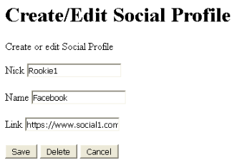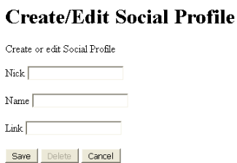

Tests

|  |  |
| --- | --- |
| Test 1 | |
| **Description** | The user creates or edit a Social Profile inserting valid data. For example:  Nick: nickAcceptanceTesting  Name: nameAcceptanceTesting  Link: http://www.linkAcceptanceTesting.com |
| **Expected** | The user will be redirected to the list of his Social Profiles (/authenticated/showProfile.do), if he was creating a new Social Profile, there should be a new Social Profile in the list with the inserted data. If he was editing, the Social Profile selected should have been correctly updated. |
| **Outcome** |  |
| **Notes** |  |

|  |  |
| --- | --- |
| Test 2 | |
| **Description** | Buttons displayed |
| **Expected** | When the user access to the Creation form, he should see a Create, delete and cancel button, but the delete button is disabled. In the edition form, the delete button is not disabled. The Cancel button redirects to the list of Social profiles and doesn’t save the data in the system (/authenticated/showProfile.do) |
| **Outcome** |  |
| **Notes** |  |

|  |  |
| --- | --- |
| Test 3 | |
| **Description** | The user provides a blank nick, name or link. |
| **Expected** | The Social Profile won’t be saved in the system and a message indicating that the corresponding field cannot be blank will be shown. |
| **Outcome** |  |
| **Notes** |  |

|  |  |
| --- | --- |
| Test 4 | |
| **Description** | The user provides an Invalid Url in the “Link” field. |
| **Expected** | The Social won’t be saved in the system and a message indicating that the link must be a valid url is shown. |
| **Outcome** |  |
| **Notes** |  |

|  |  |
| --- | --- |
| Test 5 | |
| **Description** | An XSS or SQL Sentence is inserted in the one of the fields. |
| **Expected** | The Sentence will be saved as the corresponding field of the Social Profile. The content of the sentence won’t affect the database because SQL Injections have been prevented. |
| **Outcome** |  |
| **Notes** |  |

|  |  |
| --- | --- |
| Test 6 | |
| **Description** | The user tries to edit a Social Profile that belongs to another user by inserting it id in the URL (GET hacking) |
| **Expected** | The user will be redirected to the list view (/authenticated/showProfile.do). |
| **Outcome** |  |
| **Notes** |  |

|  |  |
| --- | --- |
| Test 7 | |
| **Description** | The user edits one of this Social Profiles and clicks in the delete button. |
| **Expected** | The Social Profile will be deleted from the system and it won’t be displayed in the list view(/authenticated/showProfile.do). |
| **Outcome** |  |
| **Notes** |  |

|  |  |
| --- | --- |
| Test 6 | |
| **Description** | *The system is available in two languages, so it must work correctly in both cases.* |
| **Expected** | *Changing the language, the expected results must be obtained in all the tests indicated above.* |
| **Outcome** |  |
| **Notes** |  |

# Use case UC57: Logged as Actor, list your messages.

Description

Every actor has a pool of messages. For every message, the system must keep track of the sender, the recipient, the moment when it was sent, the subject, its body, and some optional tags.

Preconditions

*The shown views are based on the Populate Data.*

Access

*Homepage > Header Menu > Login*

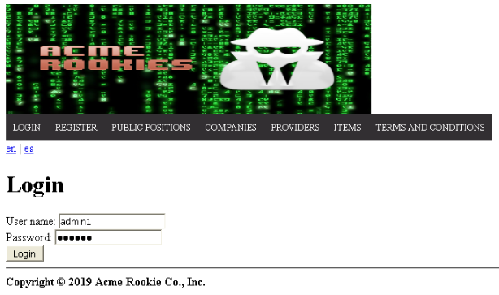

*Login as “admin1/admin1” (for example, but all the accounts of the system should be able to list his Social Profiles) > Header Menu > Profile(Username) > Messages*

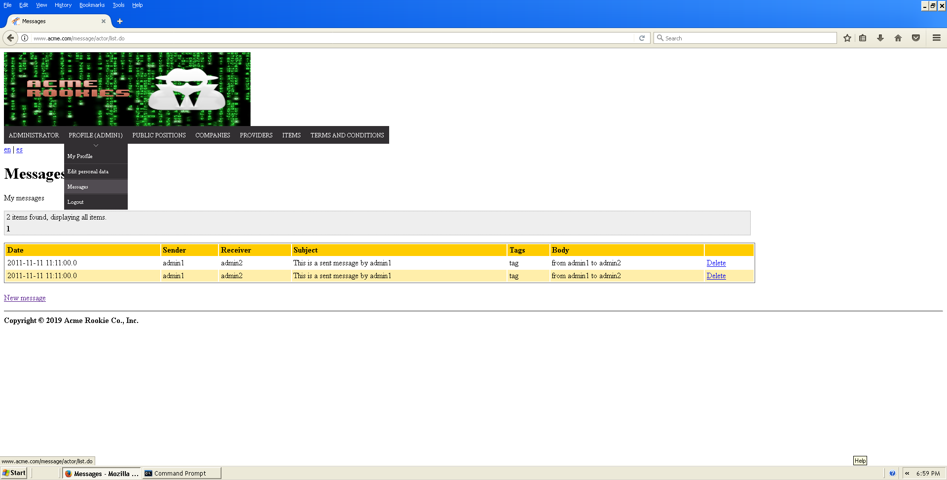

*The list of Messages that belongs to the logged actor will be displayed*

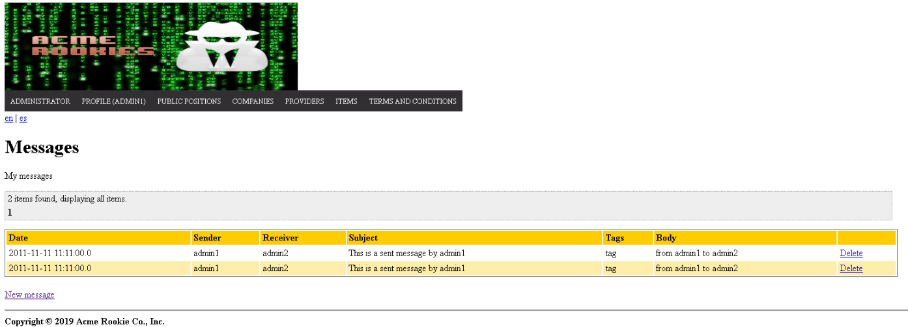

Tests

|  |  |
| --- | --- |
| Test 1 | |
| **Description** | *We must be able to see the list of messages of the logged Actor* |
| **Expected** | *In the list table there should be the following columns: Date, Sender (Username), Receiver (Username), Subject, Tags, Body. In the last column, there should be a delete link.*  *At the bottom of the table, there should be a “New message” link.* |
| **Outcome** |  |
| **Notes** |  |

|  |  |
| --- | --- |
| Test 2 | |
| **Description** | *Pagination links must work correctly* |
| **Expected** | *When the list of messages that belongs to the logged user is displayed, the pagination links must allow the user to navigate to the next, previous, first and last page. The pagination will also allow the user to select a specific page by selecting the number of that page.* |
| **Outcome** |  |
| **Notes** |  |

|  |  |
| --- | --- |
| Test 3 | |
| **Description** | *The list of messages shall be sortable by tag* |
| **Expected** | *When the list of messages that belongs to the logged user is displayed, the messages must be sortable by tag.* |
| **Outcome** |  |
| **Notes** |  |

|  |  |
| --- | --- |
| Test 4 | |
| **Description** | *Date format must be the correct one in english and spanish* |
| **Expected** | *When the list of messages that belongs to the logged user, the creation date column dates must follow the following format in english and spanish: yyyy-mm-dd hh:mm* |
| **Outcome** |  |
| **Notes** |  |

|  |  |
| --- | --- |
| Test 5 | |
| **Description** | *The user clicks on the “New Message” link* |
| **Expected** | *The user will be redirected to the creation form (/message/actor/create.do).* |
| **Outcome** |  |
| **Notes** |  |

|  |  |
| --- | --- |
| Test 6 | |
| **Description** | *The system is available in two languages, so it must work correctly in both cases.* |
| **Expected** | *Changing the language, the expected results must be obtained in all the tests indicated above.* |
| **Outcome** |  |
| **Notes** |  |

# Use case UC58: Logged as actor, send a message

Description

An actor who is authenticated must be able to manage his or her messages, which includes listing them grouped by tag, showing them, sending a message to an actor, deleting a message that he or she’s got. If a message is deleted and it doesn’t have tag “DELETED” then it gets tag “DELETED”, but it’s not actually deleted from the system; if a message with tag “DELETED” is deleted, then it’s actually removed from the system.

Preconditions

*The shown views are based on the Populate Data.*

Access

*Homepage > Header Menu > Login*

**

*Login as “admin1/admin1” (for example, but all the accounts of the system should be able to list his Social Profiles) > Header Menu > Profile(Username) > Messages*

**

*The list of Messages that belongs to the logged actor will be displayed*

**

The user clicks on the “New message” link and the following form appears:

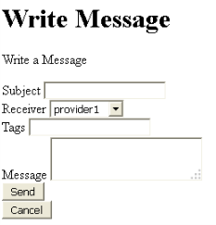

Tests

|  |  |
| --- | --- |
| Test 1 | |
| **Description** | Insert valid data in the form, the user must provide a Subject(“Subject Testing”), select a Receiver, a tag (“Tag Testing”), and a Message text(“Sample Message”). |
| **Expected** | The user will be redirected to the list of his messages (/message/actor/ list.do) and the new message will be in the list. The other actor involved in the message should get this message in his list of messages. The date of the new message will be the current date. |
| **Outcome** |  |
| **Notes** |  |

|  |  |
| --- | --- |
| Test 2 | |
| **Description** | The user clicks in the delete button in the list |
| **Expected** | The system ask for confirmation, if the user accepts, the tag of the message is changed to DELETE, if the user deletes this message again, the message will be retired from his list of messages. The message should still be in the list of messages of the other actor involved in the message. |
| **Outcome** |  |
| **Notes** |  |

|  |  |
| --- | --- |
| Test 3 | |
| **Description** | The user clicks in the “Cancel” Button. |
| **Expected** | When the user access to the Creation form, if he clicks in the “Cancel” button, he will be redirected to the list of Messages (/message/actor/list.do). |
| **Outcome** |  |
| **Notes** |  |

|  |  |
| --- | --- |
| Test 4 | |
| **Description** | The user provides a blank Subject or Message body. |
| **Expected** | The message won’t be sent and a message indicating that these fields cannot be blank will be shown. |
| **Outcome** |  |
| **Notes** |  |

|  |  |
| --- | --- |
| Test 5 | |
| **Description** | The user provides a null Receiver (POST Hacking). |
| **Expected** | The message won’t be sent and a message indicating that a Receiver must be provided must be shown. |
| **Outcome** |  |
| **Notes** |  |

|  |  |
| --- | --- |
| Test 6 | |
| **Description** | An XSS or SQL Sentence is inserted in a field. |
| **Expected** | The Sentence will be saved as the corresponding field of the message. The content of the sentence won’t affect the database because SQL Injections have been prevented. |
| **Outcome** |  |
| **Notes** |  |

|  |  |
| --- | --- |
| Test 7 | |
| **Description** | *The system is available in two languages, so it must work correctly in both cases.* |
| **Expected** | *Changing the language, the expected results must be obtained in all the tests indicated above.* |
| **Outcome** |  |
| **Notes** |  |

# Additional tests

*Apply these tests in those use cases in which they have not been explicitly defined.*

|  |  |
| --- | --- |
| Test 1 | |
| **Description** | *“Change the language to Spanish”.* |
| **Expected** | *“Every message displayed by the system must be in Spanish”.* |
| **Outcome** |  |
| **Notes** |  |

|  |  |
| --- | --- |
| Test 2 | |
| **Description** | *“Come back buttons”.* |
| **Expected** | *“All the back buttons redirect properly”.* |
| **Outcome** |  |
| **Notes** |  |

|  |  |
| --- | --- |
| Test 3 | |
| **Description** | *“Unhackeable via URL”.* |
| **Expected** | *“Even if you try to do SQL injection or you try to access to a non-public or cancelled position, the system will not let you”.* |
| **Outcome** |  |
| **Notes** |  |